Module 2: Mechanics, Materials and Waves

Mechanics:

Scalars and Vectors

Quantities in Physics are of two types: 1. scalar quantities
- vector quantities

Scalar quantities have magnitude only.

Vector quantities have both magnitude and direction.

Some examples:

Scalar | Vector
Distance | Displacement
Speed | Velocity
Mass | Weight
Energy | Force
Density | Acceleration

Definitions:

displacement, s: Straight line distance between two points.

speed, v: Change of distance in unit time (ms⁻¹).

velocity, v: Change of displacement in unit time (ms⁻¹).

acceleration, a: Change of velocity in unit time (ms⁻²).

Vector Addition and Subtraction

Vector Quantities can be represented by arrows.

Example: A girl walks due North at 3ms⁻¹ for 30s, then walks due East at 1ms⁻¹ for 20s.
- What distance does she travel?
- What is her displacement from her point of origin and what angle does her resulting displacement make with North?

(a) distance = average speed × time = (3 × 30) + (1 × 20) = 110m

Part (b) can be dealt with in two ways:

1st Way: Scale drawing
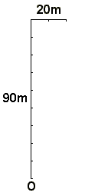

A line can then be drawn between the origin, O and the finish and measured using a ruler.

The angle this makes can be measured with a protractor.

2nd Way:

Pythagoras followed by Trigonometry

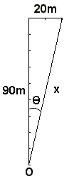
x² = 90² + 20² = 8100 + 400 = 8500

x = 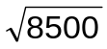= 92.2m

tanθ = 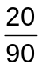= 0.22

θ = tan⁻¹0.22 = 12.5°
Some Questions:

- A aircraft with a top speed of 60ms⁻¹ leaves Manchester airport on course for Birmingham airport 160km due South. The plane’s journey is speeded up by a steady wind blowing due South, and its journey takes 40minutes.

- Assuming it traveled at top speed, calculate the wind speed.

- How long would it take to make the return journey if the wind velocity were unchanged?

- A boat has a speed of 2ms⁻¹ in still water. It is used to cross a river 500m wide along which there is a strong current of speed 0.8ms⁻¹. The boat is directed towards the oposite bank but the water current carries it downstream. Calculate:

- The boat’s resultant speed.

- The distance the boat is carried downstream from its point of departure to its point of arrival at the opposite bank.

- The time taken to cross the river.

- The time it would take to cross the river had there been no current flowing.

- Two ships, HMS Titanic and HMS Marie Celeste, leave port P at the same time. The Titanic travels due North at a steady speed of 15kmh⁻¹ and the Marie Celeste travels N60°E at a steady speed of 10kmh⁻¹.

What is the distance and direction from the Titanic to the Marie Celeste after 1 hour?
Mechanics and Maths

There are several mathematical conventions that you will need to learn in order to answer some Mechanics questions.

Resolution of Vectors

It is often convenient to replace a single vector by two components mutually at right angles to each other (see later for why).

Consider a barge being pulled along a canal by a tow rope, with force, F.

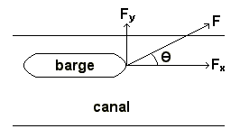
Just looking at the force and its components:
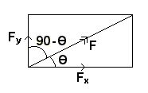
cosθ = 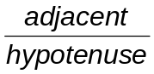 cosθ = 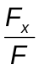 F_{x} = Fcosθ

sinθ = 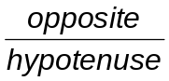 sinθ = 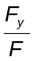 F_{y} = Fsinθ

For any force, F, acting at an angle θ, to the x axis.
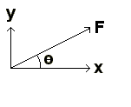

It’s magnitude horizontally, F_{x} = F cosθ

It’s magnitude vertically, F_{y} = F sinθ

Question:

What is the magnitude (vertically and horizontally) of the 50N force in the diagram below:
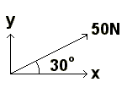

F_{x} = F cos θ = 50 cos30 = 43.3N

F_{y} = F sinθ = 50 sin30 = 25.0N

Relationship between sinθ and cosθ:

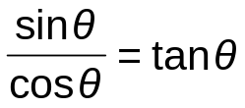
Coplanar Forces

Equilibrium

A body is said to be in equilibrium when:

- There is no resultant force – all of the force vectors (arrows) must form a closed polygon when placed top to tail.

- The principle of moments is satisfied – there is no resultant turning force about any point.

Resolving Forces

Method for solving problems in which there are more than one unknown force. For example:

The object below is held in position by three forces, find the unknown forces, T and S:
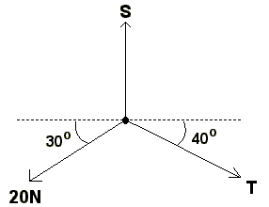

- Draw and label diagram indicating forces.

- Resolve vertically.

- Resolve horizontally.

Moments

Moments are turning forces.

For a force F, acting a perpendicular distance s, from a pivot P:

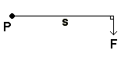
Moment = Fs

Where F is measured in N, s in metres, Moment is measured in Nm.

The Principle of Moments:

“In equilibrium, Total anticlockwise moments = Total clockwise moments.”

The following beams are all in equilibrium, in each case calculate the unknown force or distance:
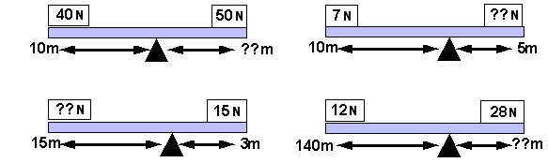

Free-body Diagrams

These indicate sizes and directions of all forces acting on an object.

The diagram below shows a beam in equilibrium:

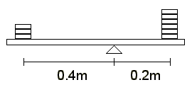

Label all the forces acting on the beam.

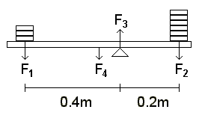
It is true to say that:

Total Anticlockwise Moments = Total Clockwise Moments

And: F₁ + F₂ + F₄ = F₃

Solving Questions with 2 Pivots:

Consider the following:

A uniform beam of weight 40N is suspended from a fixed support by two strings. The strings are attached at points A and B as shown:
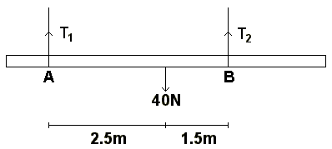

What is the tension in each string?

Principle of Moments:

In equilibrium, Anticlockwise moments = Clockwise moments
about a point about a point

About point A: T₂ × 4 = 40 × 2.5

- T₂ = 25N

About point B: T₁ × 4 = 40 × 1.5

- T₁ = 15N
Moments with angled forces:

Consider the following balanced beam, of weight 40N, suspended by two strings, both of which are positioned at angles:

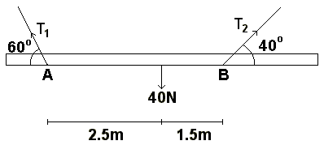

The principle of moments still applies, but…

Moment = Force × perpendicular distance to pivot.

Taking moments about A:

40 × 2.5 = (T₂ × cos50) × 4

T₂ = 38.9N

Taking moments about B:

40 × 1.5 = (T₁ × cos30) × 4

T₁ = 17.3N

Couple

A couple is a pair of equal and opposite forces acting on a body along different parallel lines of action.

e.g.
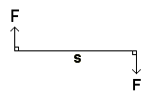
(Where s is the distance between the two forces)

The moment of a couple about any point = force × shortest distance between their lines of action.

In the above case: Couple = Fs

Explanation:

If you take moments about the midpoint to find the total turning force:
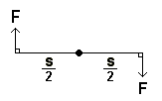 Moment = 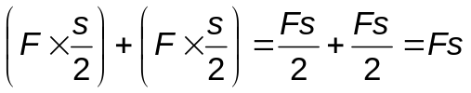
Centre of Mass

The centre of mass of a body:

- Is the point at which all of the mass of a body can be thought of to act.

- Of a symmetrical object of uniform composition is at the geometric centre of the body.

- Is the point at which a body can be balanced.

- May not necessarily lie within an object.

Mechanics Definitions:

displacement, s: Straight line distance between two points.

speed, v: Change of distance in unit time (ms⁻¹).

velocity, v: Change of displacement in unit time (ms⁻¹).
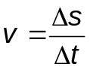

acceleration, a: Change of velocity in unit time (ms⁻²).
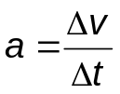

Some Qs:

- An object travels at 25ms⁻¹ in a straight line for a quarter of an hour. What is it’s displacement after this time?

- A car travels at 12ms⁻¹ in a straight line for 5 minutes, stops and reverses at 10ms⁻¹ back along its original course for 6 and a half minutes. Assuming the time taken and the distance covered while decelerating and accelerating again are equal, what is the displacement of the car?

- A car changes velocity from 24ms⁻¹ to 52ms⁻¹ in 5s. What is the car’s acceleration?

- A car changes velocity from 49ms⁻¹ to 35ms⁻¹ in 5s. What is the car’s acceleration?

- A sprinter’s acceleration is 12.5ms⁻², she accelerates for 0.8s at the start of a 100m race and runs at this speed until she finishes the race. Calculate:
- The sprinter’s top speed.
- The distance covered while accelerating.
- The total time taken to finish the race.

Displacement-time Graphs

Characteristics very similar to a distance-time graph.

Remember displacement is a vector quantity – it has both magnitude and direction.
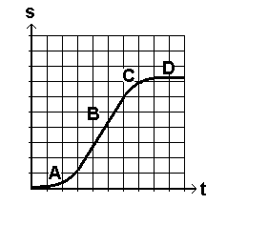

A = acceleration
B = constant velocity
C = deceleration
D = stationary

The gradient of a displacement-time graph is the object’s velocity (ms⁻¹).

Velocity-time Graphs

Characteristics very similar to a speed-time graph.

Remember velocity is a vector quantity – it has both magnitude and direction.
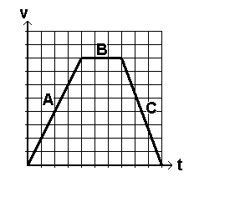
A = constant acceleration
B = constant velocity
C = constant negative accln / deceleration

The gradient of a velocity-time graph is the object’s acceleration (ms⁻²). The area under a velocity-time graph is the distance travelled (m).

Example:

For a ball thrown vertically upwards in the air, which is then caught at the original height from which it was thrown, sketch the following:

- A displacement-time graph.
- A velocity-time graph.
- An acceleration-time graph.

- displacement-time graph:

- velocity-time graph:

- acceleration-time graph:

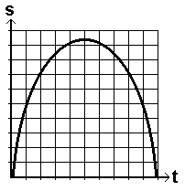
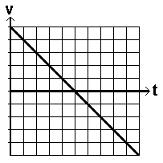
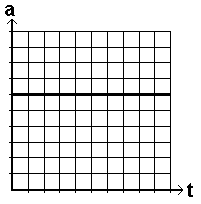
Equations of Uniform Acceleration

Consider an object uniformly accelerating from a velocity u to a new higher velocity v in a time t. A velocity-time graph of it’s motion would look like this:
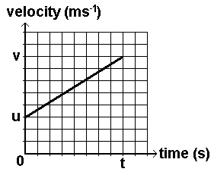

The object’s change in velocity = v – u. This occurs in a time t.

The object’s acceleration, a is equal to the change in velocity (Δv) divided by the time taken t. (The graph’s gradient).
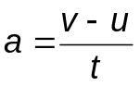
Rearranging, v = u + at Eqn.1

The object’s average velocity is equal to 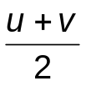and so the object’s displacement while accelerating will be equal to the average velocity × time.
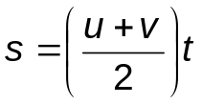 Eqn 2.
Substituting v = u + at into equation 2:

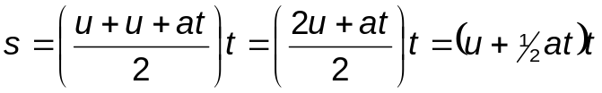

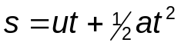 Eqn 3.
Equation 1 can be rearranged into the form: 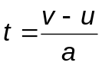

If this is then substituted into Equation 2: 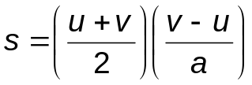 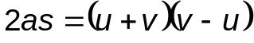

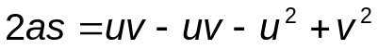

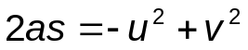

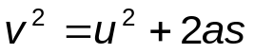 Eqn 4.
These are the four equations of uniform acceleration.

They ONLY work for CONSTANT acceleration.

Eqn 1: v = u + at
Eqn 2:
Eqn 3: s = ut + ½at²

Eqn 4: v² = u² + 2as
Projectile Motion

After the initial projection the only force acting on the projectile is gravity (assuming negligible air resistance).

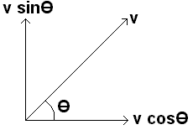
Horizontally:

- Horizontal component of v is constant: u = v
- Horizontal acceleration is zero.
- Final velocity = Initial velocity.
- Horizontal displacement = horizontal component of v × time of flight

Vertically:

- Acceleration is constant: a = g
- Equations of uniform acceleration apply.
- At maximum height, vertical velocity is zero.
- When projectile has returned to the level of the launch point, vertical displacement is zero.

Vertical displacement = s_{y}

Horizontal displacement = s_{x}

Initially, vertical component of velocity = v sinθ

horizontal component of velocity = v cosθ
Newton’s Laws of Motion

Newton’s First Law

“If a body is at rest, it remains at rest or if it is moving it travels at constant velocity unless acted upon by a resultant external force”

Newton’s Second Law

“The rate of change of momentum of a body is proportional to the applied force and occurs in the same direction”

Newton’s Third Law

“If body A exerts a force on body B, then body B exerts an equal but oppositely directed force on body A”

Answering Newton’s 2nd Law Qs:

- Sketch body.

- Mark all forces acting on that body.

- Mark on the acceleration.

- Evaluate the resultant force in the direction of acceleration.

- Apply F = ma.

Work

(Symbol: W, Units: J)

Work is done when a force moves its point of application in the direction in which the force acts.

Work is a scalar quantity; it has magnitude but no direction.

The concept of work is used for problems involving forces and displacements.

Examples:

When you lift an object, the force acts in the same direction as the displacement - the work is done on the body or against gravity.

When you drag an object, the force of friction acts in the opposite direction to the displacement - the work is done on the body or against friction.

Car with constant velocity has zero resultant force but there is work done by the engine and against the friction in the opposite direction.

Equations for Work Done:

When the force and displacement are in the same direction:

W = Fs

When the force and displacement are in different directions:

W = Fs cos θ

When the force is variable the average force must be used.

Energy

(Symbol: E, Units: Joules)

Energy is defined as that which enables a body to do work.

Conservation of Energy

Energy can’t be created or destroyed, it can only be transformed from one form to another.

There are only 2 types of energy: potential (E_{p}) and kinetic (E_{k}).

Total amount of mechanical energy (E_{p} + E_{k}) possessed by the bodies in an isolated system is constant.

The efficiency of a machine is defined as:
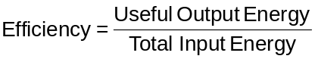 or 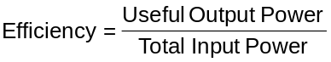

Potential Energy

The energy possessed by a system of bodies due to their relative positions and the force fields experienced by them.

Change in potential energy, ΔE_{p} = mgΔh

Kinetic Energy

The energy possessed by a body due to its mass and speed.

Kinetic energy, E_{k} = 1/2mv²

Change in kinetic energy: ΔE_{k} = 1/2mv² - 1/2mu²

Power - The rate at which work is done.

Units: Watts or Joules sec⁻¹.

If a constant force (F) is applied, and does work by moving its point of application a distance (s) in time (t), then the power is given by:
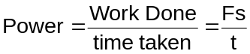

However s/t is an expression for the velocity of an object so the equation becomes:

P = Fv

When solving Power problems, this equation isn’t always used.

Sometimes (e.g. Questions involving pumps) you need to use energy considerations (E_{k} and/or E_{p}).

Some Questions:

- A force of 50N is used to lift a load a height of 5m in 10s.
- What is the work done against gravity?
- What power is developed?

- A pump is used to raise water a height of 15m and ejects it with a velocity of 20ms⁻¹ vertically upwards. If the pump ejects water at a rate of 4kg every second, what is the power of the pump?

- A pump is positioned directly on top of a reservoir. It ejects water through a nozzle of area 6cm² at a velocity of 10ms⁻¹ straight up. At what power is the pump working?
Elastic Properties of Solids:

The density of an object is the ratio of the object’s mass to its volume:

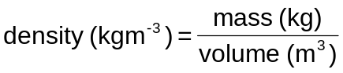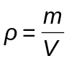

The table below shows the densities of a large number of different materials:

Material | Density  (kgm⁻³)
Interstellar space | ∼10⁻²⁰
Air in “vacuum” in TV tube | ∼10⁻⁷
Air at 0°C and 1 atmosphere | 1.29
Air at 100°C and 1 atmosphere | 0.95
Air at 0°C and 50 atmospheres | 65
Balsa wood | 150
Ethanol | 810
Ice at 0°C and 1 atmosphere | 920
Water at 100°C and 1 atmosphere | 958
Water at 0°C and 1 atmosphere | 1000
Water at 0°C and 50 atmospheres | 1002
Aluminium | 2700
Iron | 7800
Copper | 8900
Lead | 11,300
Mercury | 13,600
Gold | 19,300
Osmium (densest element) | 22,500
Centre of Sun | 160,000
White dwarf stars | ∼10⁹
Atomic nuclei | ∼10¹⁶

Stress and Strain

If forces are applied to a material in such a way as to deform it (extended or compressed) the material is being stressed.

Stress is the force per unit area of cross-section.

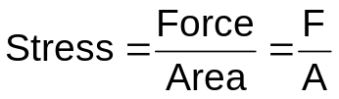

Force measured in Newtons, N.
Area measured in metres², m².
Stress measured in Nm⁻² or Pa.

As a result of the stress the material becomes strained.

Strain is the extension per unit length.

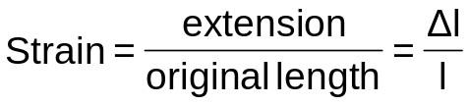

Pure number – no units.

Stress which results in an increase in length is called tensile stress and causes tensile strain.

Hooke’s Law

Up to some maximum load, known as the limit of proportionality, the extension of a wire or a spring is proportional to the applied load.

F = kΔl

Where F is the load, e, the extension and k is the spring constant (Nm⁻¹).

The value of the spring constant is the force required to produce unit extension.
A Stress – Strain Curve of an elastic material (a metal wire):

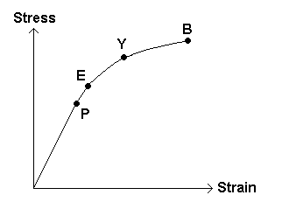

P = Limit of Proportionality

E = Elastic Limit: Max. load a body can experience and still return to original size and shape once load is removed.

Y = Yield Point: Marked increase in extension, plastic behaviour.
Few materials exhibit a yield point, mild steel is one that does.

B = Breaking Point: If the stress is increased beyond this value, the material breaks.

Some Definitions:

Strength: Max. force that can be applied to a material without it breaking.

Stiffness: A measure of the difficulty of changing the shape of a material.

Brittle: Stiff materials but not very strong. E.g. glass.

Hardness: A measure of the difficulty of scratching a material.

Creep: Material continues to extend despite force remaining constant. E.g. polythene.
Stress-Strain Graphs for Different Materials

Metals – See previous graph.

Metals are: Strong (Large breaking stress)
Stiff (Large Young Modulus)
Tough (Don’t crack easily)
Ductile (Can be drawn into wires)

Metals behave plastically beyond the elastic limit and are, therefore, not brittle.

Typical Amorphous Material E.g. Glass

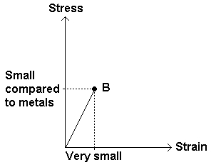
Behaves elastically throughout.

Compared to metals: Not as strong
Not as stiff
Brittle (abrupt end)

Typical Polymeric Material E.g. Rubber

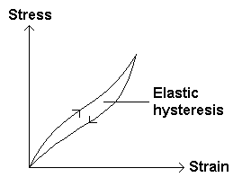
Unloading extension lags behind the loading extension.

The effect is known as elastic hysteresis.

When rubber is stretched it becoms warmer and takes time to return to its original temperature.

The area of the hysteresis curve is equal to the increase in temperature of the sample during the cycle.

Removing Stress after Plastic Deformation:
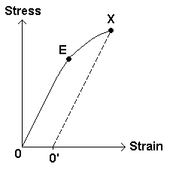
The graph opposite is of a (hypothetical) elastic material that has been extended beyond its elastic limit, E. At point X, the stress has been removed and the material contracts.
Strain Energy (Elastic Potential Energy)

- The energy which is stored in a material when it is strained due to applied stress.

Stress-Strain Graphs

Metal stretched beyond elastic limit:
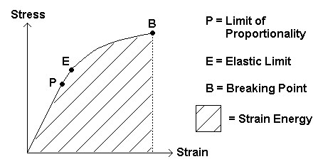

Metal unloaded:
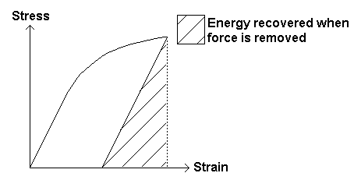
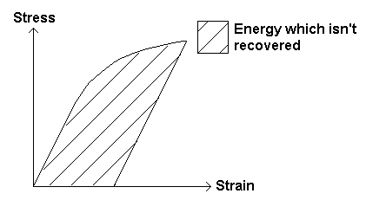
The Young Modulus

Provided the stress is not so high that the limit of proportionality has been exceeded, the ratio of stress / strain is a constant for a given material and is known as the Young Modulus, E.

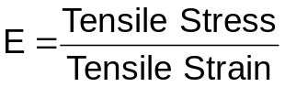

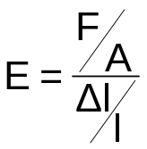 or 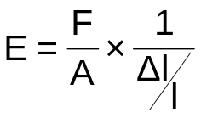

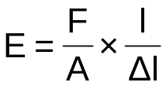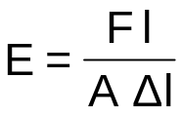

Units of the Young Modulus are Nm⁻² or Pa.

The Young Modulus is a measure of a material’s resistance to changes in its length.

E_{Rubber} = 1 × 10⁶Nm⁻²

E_{Steel} = 2 × 10¹¹Nm⁻²

Some Questions:

- An unknown material, original length 3m, extends 120mm when a load of 100N is suspended from it. The material’s cross-sectional area is 1mm². What is the Young Modulus of the material?

- A 1000N load is suspended from a steel wire of original length 8m. The cross-sectional area of the wire is 1.25mm². What extension is produced?

- A metal wire has a Young Modulus of 2.5 × 10¹⁰Nm⁻² and is of length 4m. A load of 2400N is suspended from its end and produces an extension of 2mm, what is the diameter of the wire?

Experimental Determination of the Young Modulus

Apparatus Diagram:

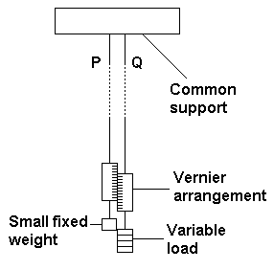
Points to note:

- Common support means that any sagging of the support is irrelevant.

- The wires P and Q are made from the same material and are the same length to ensure expansion is not a problem.

- Small fixed weight to keep P taut.

- Wires are long and thin too ensure extension is as large as possible.

- Vernier arrangement measures the extension.

- Micrometer measures the diameter.

- Tape-measure measures original length.

- Use of w = mg to calculate load.

Energy Stored Derivation

The tension, F in a spring whose extension is Δl, which obeys Hooke’s Law is given by:

F = kΔl

Where k is the spring constant (also called stiffness constant).

The graph below is of an elastic material being stretched:

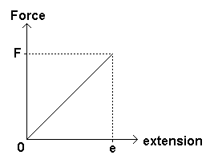

The average force exerted is 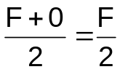

Work Done = Force × Distance

W = ½ FΔl

Substituting for F with F = kΔl

W = ½ kΔl²

Some Questions:

- A 500g mass is attached to the end of a spring which obeys Hooke’s Law and produces an extension of 20cm. Calculate the spring constant, k, and the energy stored in the spring.

- A spring has a spring constant of 40Nm⁻¹.
- What extension will a force of 40N produce? What does this tell you about the spring constant?
- What load would need to be suspended from the spring for it to store 12J of energy?
Breaking Stress

- The breaking force per unit area of a material (the breaking force being at right angles to the material).

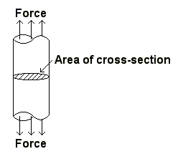

If we are given the fact that the breaking stress for a certain type of steel is 10⁹Nm⁻², we can work out the breaking force for any wire or cable of known diameter.

Breaking Force = Breaking Stress × Area of cross-section

Question:

For the given breaking stress for steel, calculate the breaking force for a wire of diameter 0.5mm.

Breaking Force, F = 10⁹ × π( ½ × 0.5×10⁻³)²

F = 197N

Progressive Waves

A progressive wave is the movement of a disturbance from a source, which transfers energy and momentum from the source to places around it.
Waves are of two fundamental types:

- Mechanical waves, which require a material medium for their propagation.
- Electromagnetic waves, which can travel through a vacuum.

All types of wave motion have the same basic properties and can be treated analytically by equations of the same form.

Wave Characteristics

- Waves transfer energy, there is no transfer of matter.
- In a mechanical wave the medium has particles which have inertia and elasticity (some means of interacting with their neighbours). These particles execute oscillations of small amplitude about their equilibrium positions.
- Each particle oscillates in the same way as its neighbour, but shows a time lag if it is further from the source of energy.

Longitudinal and Transverse Waves

A wave is said to be:

- Longitudinal if the displacement of mechanical particles is parallel to the direction of the translation of energy.
- Transverse if the wave has associated with it some displacement which is perpendicular to the direction of translation of energy.

Examples of Progressive Waves

Wave Type | Nature of Disturbance | Possible Result of Energy Transfer
Water waves | Water molecules describe a periodic motion in a closed path | Oscillation of a floating body
Sound waves | Vibratory motion superposed on random motion of air molecules | Diaphragm of a microphone set oscillating
Secondary earthquake waves | Shaking motion (transverse) of material in Earth’s crust | Buildings collapse
Electromagnetic waves | Transverse variation of E and B fields | Could stimulate retina of human eye

A plot of displacement against time shows the nature of the oscillation of a particle at a particular location.
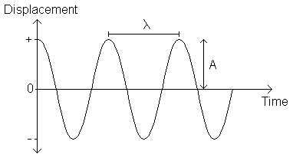
The wavelength λ is the spatial period of the wave pattern at a fixed instant, and is therefore the distance between two consecutive particles, which have the same phase (The distance between two successive crests, for example).

The amplitude A is the maximum displacement of a particle from its equilibrium position.

The frequency of the wave is the number of vibrations performed in each second by the source, and is thus the number of waves that pass a fixed point in each second.

The speed c of a mechanical wave is that with which an observer must move so as to see the wave pattern apparently stationary in space.

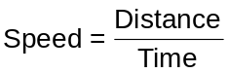

If in a time T, 1 wave of wavelength λ passes a fixed point, its speed c is given by:
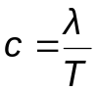 However, 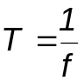 so substituting, c = fλ

Question: An oscillator produces 25 sound waves in 2.5s. Assuming that the speed of sound in air is 330ms⁻¹ what is the wavelength of these waves? 33m.
Phase

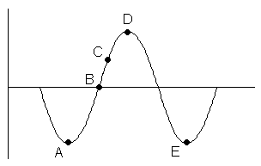
The particles in the path of a mechanical wave vibrate with the same amplitude as each other but their vibrations are out of phase, they are not all at the same point in their vibration.

Consider four corks floating in the sea as a water wave passes them:
Since the corks are at different positions, taking a “snapshot” of the situation it is clear that while cork A is in a trough, B is at its equilibrium position, C is halfway up a wave and D is at the crest of a wave. The corks are “out of phase” - they lag behind one another. However, cork E and cork A will mirror each other’s movements – they are in phase with each other.

The path difference is usually expressed as a fraction of a complete wave cycle. One wave cycle is analogous to a complete circle and one wave cycle is said to be equivalent to 360°. Particles in phase are multiples of this no. of degrees apart. Particles that are a whole no. of wavelengths apart (λ, 2λ, etc. - phase difference of 360° or 720°) are in phase with each other. Particles that are λ/2 (phase difference 180°) apart are said to be in antiphase as each particle is doing the opposite of the other one, this happens when particles are an odd multiple of λ/2 e.g. 3λ/2, 5λ/2, etc.

To calculate the phase difference, the following equations can be used:

To express the phase difference in degrees:
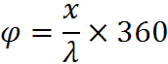

To express the phase difference in radians:
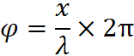

In both equations, x is the distance between the points on the wave and λ is the wavelength. The units for the distance and the wavelength need to be the same.

Polarisation

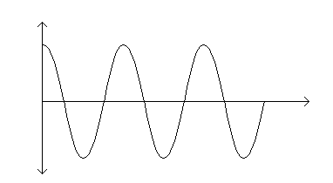
Oscillators producing transverse waves don’t produce them in just one plane they can be produced in many planes. A visual example will help; here is a wave in one plane:
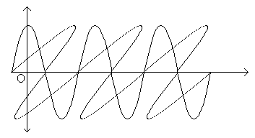
Here are two waves travelling in different planes to each other:
Polarisation is used to distinguish between transverse waves and longitudinal waves.

Transverse waves are waves where the vibrations are perpendicular to the direction of propagation of the waves. Examples include electromagnetic waves, waves on a vibrating string and secondary seismic waves.

Longitudinal waves are waves where the vibrations are parallel to the direction of propagation of the waves. Examples include sound waves and primary seismic waves.

Transverse waves are linearly polarised if they vibrate in one plane only. Unpolarised transverse waves vibrate in a randomly changing plane.

Light from non-laser sources is unpolarised but can be polarised by passing it through a polaroid filter, one type of which consists of molecules aligned in parallel lines. If polarised light is incident on a second polaroid 'analyser' filter, the intensity of the light transmitted by the filter is greatest if the molecules are parallel in the two filters, and is least if the filters are aligned so their molecules are perpendicular.

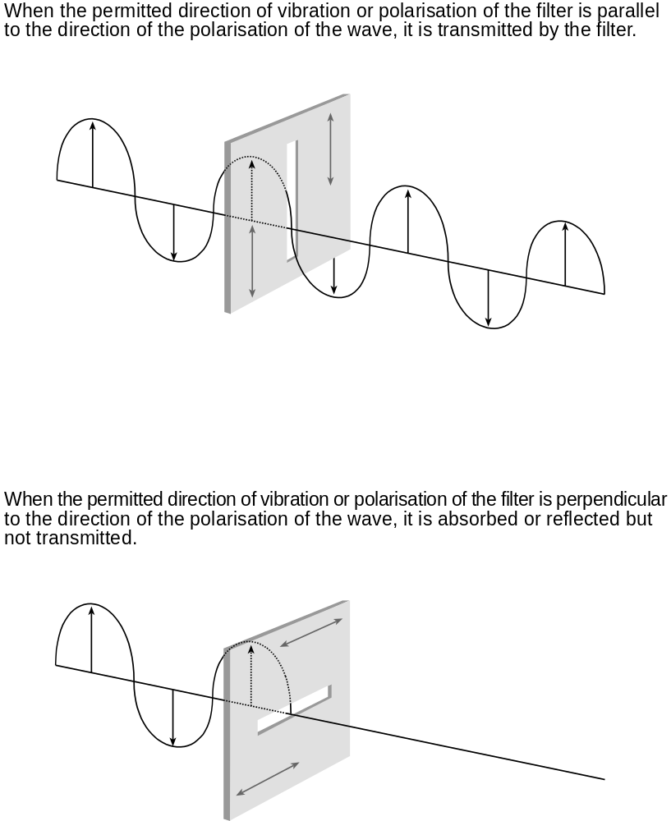
Refraction

Light is refracted as it travels from one medium to another due to a difference in optical density.

The light slows down or speeds up and this is what causes the refraction (or bending of the light rays).

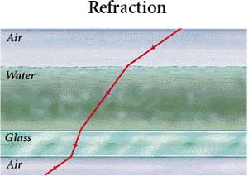

Applications of Refraction

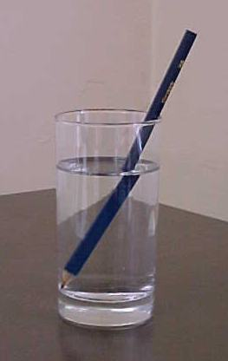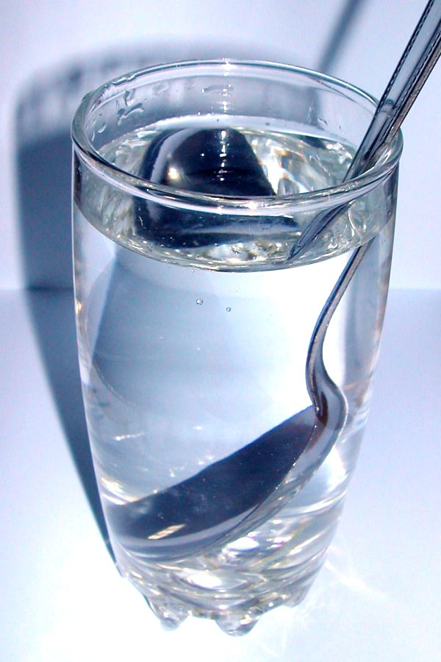

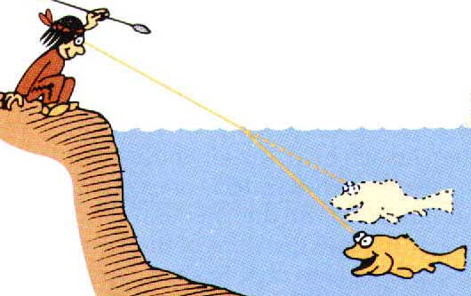

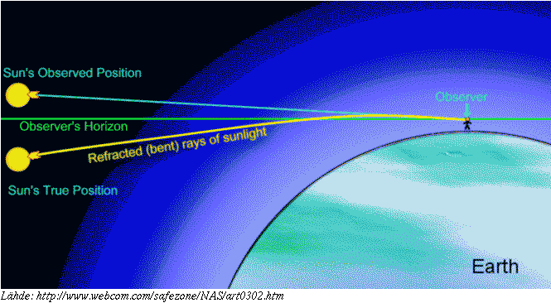

Snell’s Law of Refraction

“When a ray of monochromatic light travels from a less dense material to a more dense material it will bend towards the normal (provided it approaches the boundary at an angle other than 90º).” The converse statement also applies.

The reason light refracts was first postulated by Fermat who suggested that light takes the shortest route between two points.

The absolute refractive index of a material is the ratio of the speed of light in a vacuum (3×10⁸ms⁻¹) to the speed of light in the material.
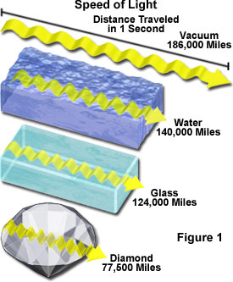
Material | Refractive index
Vacuum | 1.00000
Air (at STP) | 1.00029
Ice | 1.31
Water at 20ºC | 1.33
Glass (Typical) | 1.52
Sapphire | 1.77
Diamond | 2.417

The speed of light in water, for example is 225,000,000ms⁻¹.

The ratio of 300,000,000:225,000,000 is 1.33 – this is the absolute refractive index for water!
The refractive index n, of a substance s is given by: n = 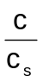 where c is the speed of light in a vacuum and c_{s} is the speed of light in substance s.

Relative Refractive Index

When light travels from one medium to another it will refract a certain amount depending on the refractive indices of the two materials.

This is called the relative refractive index.

Its value can be found if the speed of light in the two materials is known.

n₁ sin θ₁ = n₂ sin θ₂

θ₁ is the angle of incidence.
θ₂ is the angle of refraction.
n₁ is the refractive index of material 1
n₂ is the refractive index of material 2

Total Internal Reflection

When a ray of light travels from a more dense to a less dense medium it bends away from the normal.

At an angle, called the critical angle, the ray of light is no longer refracted, but totally internally reflected.

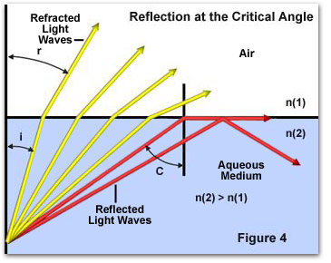

This only occurs when the ray travels from a more dense to a less dense medium.

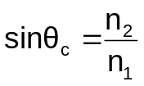
Where θ_{c} is the critical angle.
n₁ is the refractive index of material 1
n₂ is the refractive index of material 2
(Where the ray of light travels from material 1 to material 2)

Uses of Total Internal Reflection

Fibre Optics – Used in communication, endoscopy.

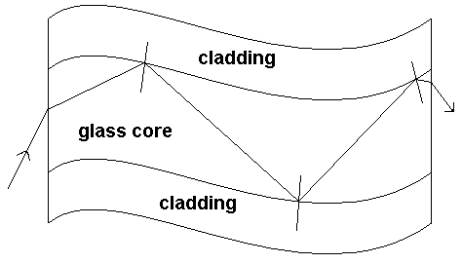

Cladding is made of glass with a lower refractive index than the glass core so that total internal reflection can occur.

It protects the inner core from scratches and prevents light escaping to adjacent fibres.

Critical Angle and Fibre Optics

A ray of light could be incident between ~0º and 90º to the normal.
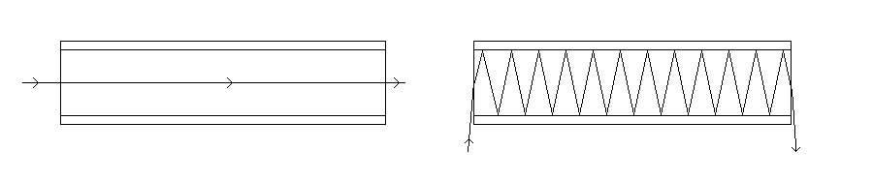
A small critical angle is good for fibre optics as there is a greater chance of propagation of the ray of light.

Cladding and Fibre Optics

Cladding must have a lower refractive index than the core so that TIR can occur.

It also provides a second chance at total internal reflection:

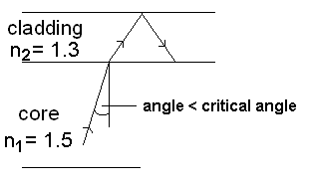
The critical angle for the core-cladding boundary is:

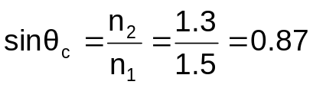 so θ_{c} = 60º

The critical angle for the cladding-air boundary is:

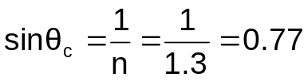 so θ_{c} = 50º

Superposition of waves, stationary waves

The principle of superposition states that the resultant displacement caused by two waves arriving at a point is the vector sum of the displacements caused by each wave at that instant.
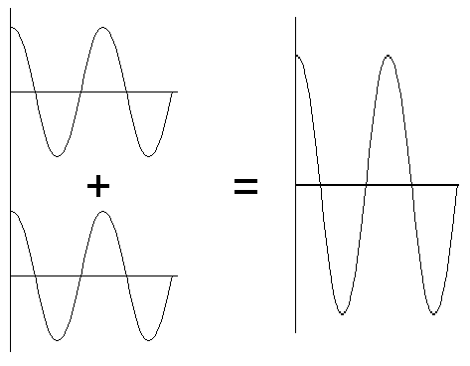
e.g.

Waves arriving in phase with each other add together constructively.

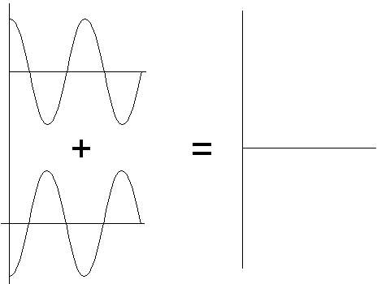

Waves arriving 180° out of phase with each other add together destructively.

Student activity: Plot 2 graphs on a sheet of graph paper, same amplitude, different frequencies. Let Graph 1 = f and Graph 2 = 2f and then sum them for superposition. The phenomenon of beats is observed.

Stationary or standing waves result from superposition of two wavetrains, which have:
- The same amplitude and frequency (and therefore wavelength)
- Equal but opposite velocities.

A stationary wave is one in which some particles are permanently at rest (nodes), while others vibrate in phase but with varying amplitudes. The maximum amplitude occurs midway between the nodes (antinodes).

The formation of stationary waves is a special case of interference.

It is convenient to describe the result of superposition in terms of what would be observed using transverse waves on a stretched spring. The eye sees a time-average, and cannot distinguish between the phases of adjacent segments, whereas a photograph can.

Comparison of stationary and progressive waves:

 | Stationary | Progressive
Amplitude | Varies according to position from zero at the nodes (permanently at rest) to a maximum of 2A at the antinodes. | Apart from attenuation, is the same for all particles in the path of the wave.
Frequency | All the particles vibrate in SHM with the same frequency as the wave (except for those at the nodes which are at rest). | All particles vibrate in SHM with the frequency of the wave.
Wavelength | 2× distance between a pair of adjacent nodes or antinodes. | Distance between adjacent particles which have the same phase.
Phase | Phase of all particles between two adjacent nodes is the same. Particles in adjacent segments of length λ/2 have a phase difference of π rad. | All particles within one wavelength have different phases.
Waveform | Does not advance. The curved string becomes straight twice in each period. | Advances with the velocity of the wave.
Energy | No translation of energy, but there is energy associated with the wave. | Energy translation in the direction of travel of the wave.

Waves on Strings

Stationary waves occur on a guitar when a string is plucked, with nodes at the two ends and an antinode in the middle.
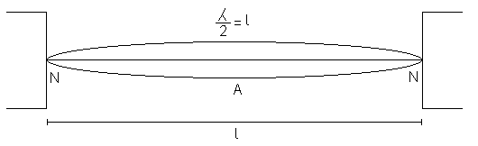
e.g.

This is the simplest wave that can be set up and is therefore called the fundamental or the (first) harmonic.
The frequency, f₀, of the fundamental is given by 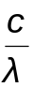, if the string has a length l and a wavelength of 2l, the fundamental frequency, 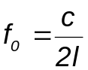 where c is the speed of the wave along the string.

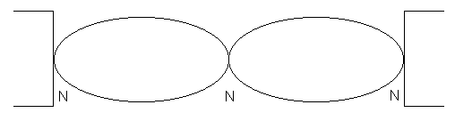
More complex waves are also possible, for example the diagram below has a node in the centre of the string and is called the first overtone or the second harmonic.
The frequency of this wave is 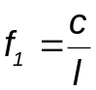 (twice the frequency of the fundamental).

Path Difference
Consider two sound waves leaving two speakers produced at the same time. The two waves are in phase with each other, but an observer will hear different levels of loudness depending on his distance from each speaker. This is due to the different distances travelled by each wave.
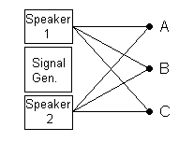
e.g.
B: Equidistant from the speakers, waves are in phase as they have travelled the same distance.
A and C: Each wave travels a different distance, there is a path difference. If the waves are out of phase by anything but a whole number wavelengths the sound will appear quieter than normal. If the waves are out of phase by a whole number of wavelengths they will add constructively to produce a loud sound.

For the loudest sound (maximum):

Path difference = n (λ/2) where n = 0, 2, 4, etc.

For the quietest sound (minimum):

Path difference = n (λ/2) where n = 1, 3, 5, etc.

To observe constant maximums and minimums – an interference pattern – the following conditions must be met:

- The sources must be coherent i.e. Produce waves with constant or zero phase difference. Therefore, frequencies must be the same. (If not coherent, the interference pattern would change rapidly and continuously)
- The waves from the 2 sources must have equal or similar amplitudes. (There will be incomplete destruction if amplitudes are dissimilar.)
- If the sources produce transverse waves the waves must be unpolarised or polarised in the same plane.

The reason interference patterns aren’t observed with light is that there is no constant phase difference between two light sources – it is constantly changing.

One way to observe an interference pattern with light is to pass coherent light through two slits in a screen. The slits are VERY close together.
Young’s Two Slit Experiment

One of the first demonstrations of the interference of light waves was by Young in 1801. He placed a source of monochromatic light in front of a narrow slit, and arranged two very narrow slits close to each other, in front of the first slit. Young then saw bright and dark bands on a screen in front of the two slits.
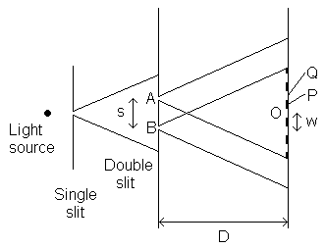
The first slit is required so that the source of light can be considered to be a point source, the two slits are required so that a path difference can be set up.
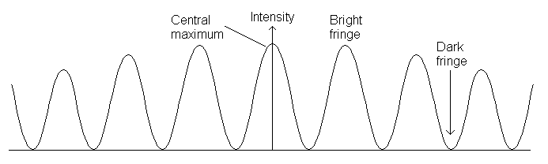
Q P O

The light coming from the two slits have the same frequency and are always in phase with each other since the two light beams originate from the same source.Interference occurs where the two light beams overlap. As AO = OB a bright band is obtained at O. At a point close to O, such that 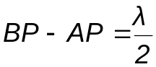 where λ is the wavelength of the light from the source, a dark band is obtained. At a point Q such that BQ – AQ = λ, a bright band is obtained; and so on for either side of O. Young demonstrated that the bands or fringes were due to interference by covering A or B – the fringes disappeared.

The distance between two successive maxima w can be found using the equation:
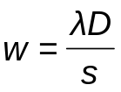
where λ is the wavelength of the light used, s the separation of the two slits and D the distance from the slits to the screen.
Diffraction
Diffraction is important in optical devices such as microscopes and telescopes and in communications.

Diffraction is the spreading of waves after passing a gap or by the edge of an obstacle.

The amount of diffraction of waves passing through a gap increases if the gap is made narrower or if the wavelength of the waves is increased.

In the diagram below the amplitude at P is found by superposing wavelets originating in the gap. It differs from what would be observed in the absence of the obstacle because:
1. The obstacle removes some secondary wavelets from the wavefront.
2. The secondary wavelets originate at differing distances from P.

This:
- Affects their relative amplitudes.
- Controls their phase relationships.
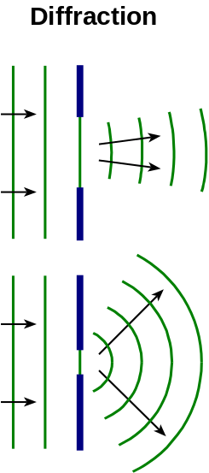
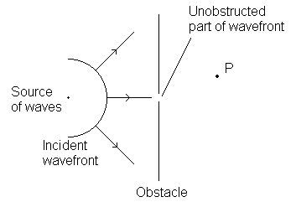

When diffraction at a gap occurs, part of each wavefront only passes through the gap.

Each wavefront emerging through the gap is shorter than it was.

The wavelets from each restricted section spread out to re-create wavefronts that spread out.

The greater the restriction of the wavefronts, the more significant the effect of wavelets from the ends of the restricted wavefronts so the greater the spreading.

Diffraction of Light at a Single Slit
Monochromatic light passing through a single narrow slit into a microscope or onto a screen produces a pattern of bright and dark fringes. The intensity varies with direction.
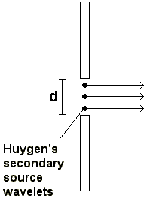

All rays in phase (no path difference), constructive interference produces a broad central maximum.

A path difference exists across the aperture so that rays originating from different points across the aperture will interfere constructively and destructively to give an interference pattern like the diagram below:

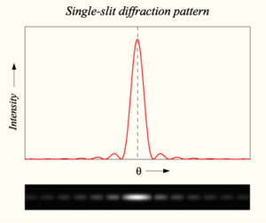
The pattern has a broad central maximum and subsidiary maxima are much smaller and much narrower than the central maximum.
The Diffraction Grating

Gratings are used to diffract a light beam into spectra, which can then be measured.
A grating is a plate with a large number of parallel grooves ruled on it.

Transmission Grating
A transmission grating is a flat glass plate or plastic with parallel grooves which transmits and diffracts light into spectra.

When a narrow beam of monochromatic light is directed normally at a transmission grating, the beam passes through and is diffracted into well-defined directions given by the diffraction grating equation:

d sin θ = nλ

where d, the grating spacing, is the distance between the centres of adjacent slits and n is an integer, referred to as the order number.
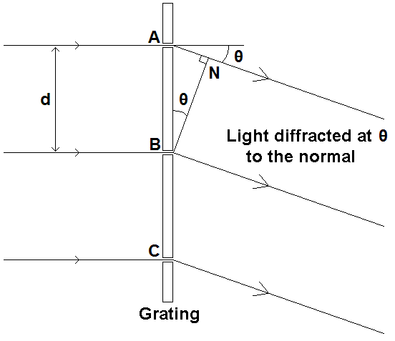
The slits are equally spaced and, therefore, if θ is such that light from A is in phase with that from B, it is also in phase with light from every slit. This happens when AN = nλ where n = 0, 1, 2, etc.

Points to note:

White light source - a continuous spectrum is observed at each order, always with blue towards the central n = 0 order and red away from the centre.

This is because blue light has a smaller wavelength than red light so is diffracted less.

The spectra at higher orders begin to overlap because of the spread.

Using light sources that emit certain wavelengths only, a line emission spectrum is observed which is characteristic of the atoms in the light source.

Such a spectrum consists of sharp vertical coloured lines separated by darkness. Each coloured line is due to a specific electron transition in the atoms of the source, see below:


