Unit 5D: Turning Points in Physics

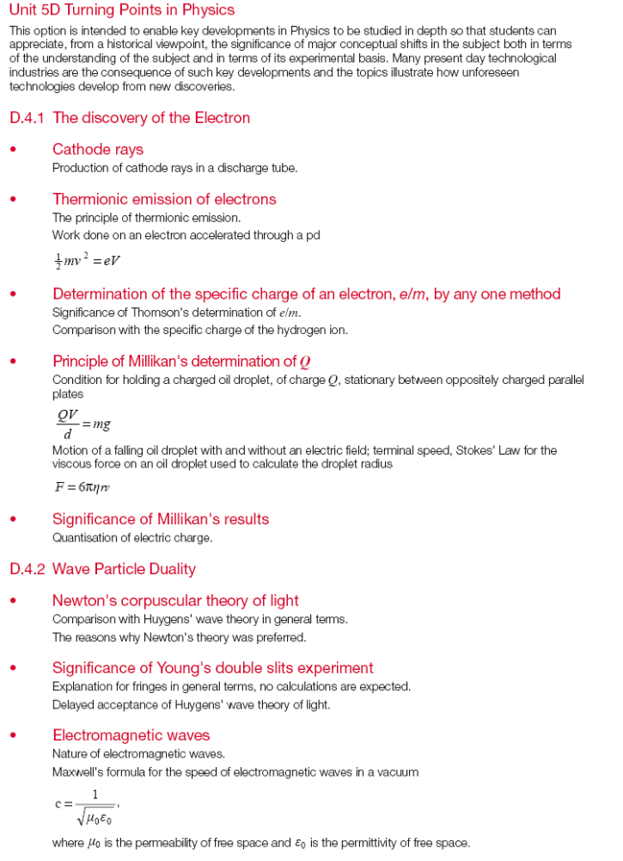
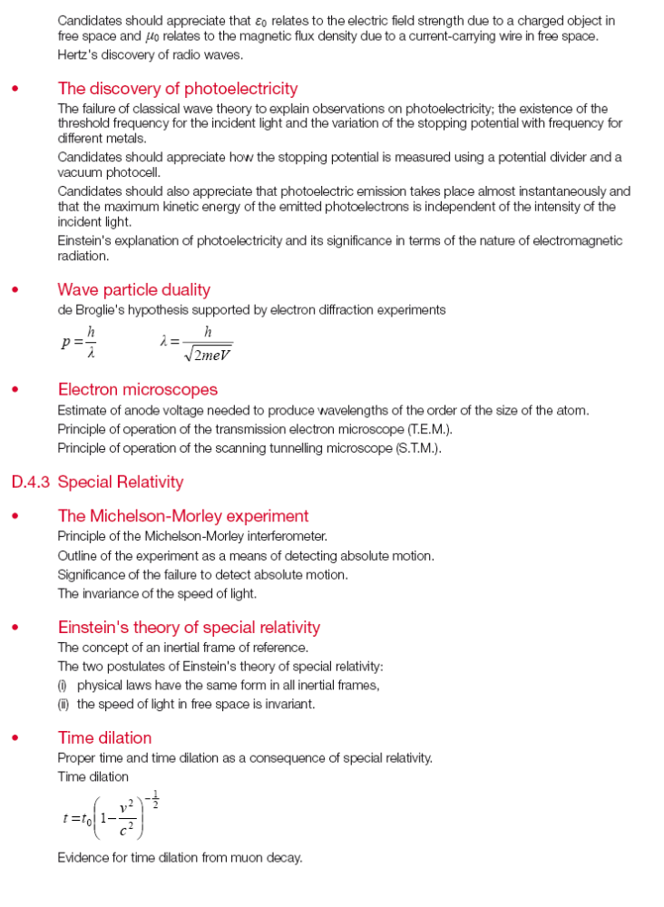
Turning Points in Physics

Cathode Rays

The electron was discovered by JJ Thomson in 1897.
It’s discovery was due mainly to phenomena known as cathode rays.

An evacuated tube is connected in a circuit as shown below:

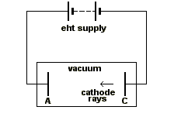
The low pressure gas remaining in the tube glows when the circuit is turned on.

The colour of the glow is characteristic of the gas used (Energy levels).

The glass behind the anode glowed as well, it was assumed, therefore, that rays were streaming from the cathode and were termed “cathode rays”.

To carry out experiments using these rays a small hole was made in the anode so that some of the rays would stream through. Electrons are accelerated due to a p.d. The anode is earthed so once the electrons have passed it no p.d. exists – they just carry on!

These experiments demonstrated that:
- Cathode rays transfer energy, momentum and mass.
- Cathode rays transfer a negative charge.
- The charge to mass ratio (called specific charge) is much larger than that for hydrogen ions.
- Cathode rays have the same properties whatever gas is used in the tube, and whatever metal is used as the cathode.

Thermionic Emission

These experiments are now carried out by heating the cathode, which increases the thermal energy of the electrons. They leave the surface more easily – like evaporation. The heating of the cathode is termed “thermionic emission”. The whole device is mounted in a vacuum and called an “electron gun”.

Work done on Electrons

The work done on an electron accelerated through a p.d is given by:

½mv² = eV

Q. An electron is accelerated to a speed of 10⁸ms⁻¹. Through what p.d. was it accelerated?
The Specific Charge of an Electron

Thomson was correct and cathode rays were particles not rays and they carry a negative charge.

One of the most important facts was the specific charge, which if calculations were correct was about 1840 times that of a hydrogen ion.

One way of measuring it is to use a fine-beam tube.

A deflection tube only shows the beam when it hits a fluorescent screen. The fine-beam tube contains low-pressure helium which is ionised by the electrons in the beam and emit photons of visible light as they recombine with electrons to become helium atoms.

This means the beam is visible all the time and if a magnetic field is applied perpendicular to the beam direction the electrons can be made to move in a circular path.
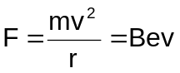

From the equation for work done accelerating electrons with a p.d.

½mv² = eV, 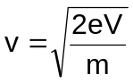

Giving: 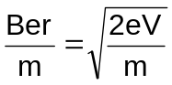 or 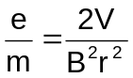

All of the quantities can be measured, V the accelerating p.d., B the magnetic field strength and r the radius of the circular path.

The accepted value for e/m_{e} is 1.76 × 10¹¹ Ckg⁻¹.

The idea that the particles were fundamentally different from any particle known at the time was strongly supported by Thomson’s value for their specific charge. This was of the order of a thousand times that of the hydrogen ion as found from electrolysis experiments, and this was the highest of any known particle.

The relatively high value of the specific charge of the cathode ray particles could be due to them having a large charge, or a small mass, or both. Thomson assumed that they had the same charge as a hydrogen ion, in which case they must be particles of very small mass.

Note: The specific charge of a hydrogen ion is 9.58 × 10⁷ Ckg⁻¹.

Cathode rays from all elements are identical, so these particles must be found in all atoms. Thomson concluded that the electron is a subatomic particle.

Stokes’ Law

Viscosity is internal friction between different layers of a fluid moving with different velocities.

Any object moving through a fluid will experience an opposing frictional force that depends on several factors:

- The size of the object - larger object = larger frictional force
- The velocity of the object - higher velocity = larger frictional force
- The coefficient of viscosity - larger coefficient = larger frictional force

(Weight is the downwards force and does not affect the frictional force, it is included as the velocity factor – heavier object = higher terminal velocity)

The coefficient of viscosity of a fluid is a measure of the degree to which the fluid exhibits viscous effects. The higher the coefficient of viscosity, the more viscous the fluid – golden syrup at room temp. is 10⁵× that of water at the same temp.

The symbol for the coefficient of viscosity is η. The units of which are Nsm⁻² = kgm⁻¹s⁻¹.

Consider the object below:
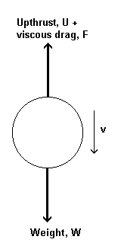
Three forces act on an object moving through a fluid:

1. Gravity acting downwards due to the object’s mass.
- The frictional force acting on the object.
- The force of upthrust (equal to the weight of water displaced by the object).

At the terminal velocity: U + F = W - Eqn 1

And F = 6πηrv

This equation was first derived by Stokes and is known as Stoke’s law.

Upthrust (The weight of fluid displaced) = 4/3 π r³ ρ_{f} × g

The weight of the ball bearing = 4/3 π r³ ρ_{s} × g

Substituting these 3 relationships into equation 1 above we get:

4/3πr³ρ_{f}g + 6πrηv = 4/3πr³ρ_{s}g

And can be rearranged to: 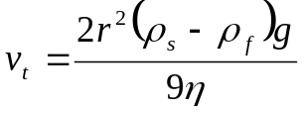

This equation can be utilised to measure the coefficient of friction for liquids of high viscosity such as glycerine or treacle. Fluids of low viscosity require a different approach.

The liquid whose coefficient of viscosity is being determined is contained in a large measuring cylinder. A small ball bearing of radius r is dropped gently into the liquid. The time taken for the ball to fall from mark A to mark B is determined. Providing A is sufficiently far below the surface, the bearing will have reached it’s terminal velocity, v_{t} before reaching A, in which case v_{t} = AB/t. If ρ_{f} and ρ_{s} are the densities of the liquid and sphere respectively, then from the above relationship:

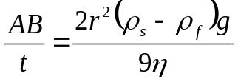

A micrometer can be used to measure r; ρ_{f} and ρ_{s} are found from tables or are determined in additional experiments; hence η can be deduced.

Notes:
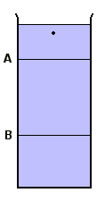
- Stokes’ law applies strictly only when the fluid is of infinite extent. The error due to the impossiblilty of fulfilling this condition is reduced by using a measuring cylinder which is wide compared with the diameter of the ball-bearing, and by having B well away from the bottom.

- If the velocity of the ball-bearing is so large that it produces turbulence, Stokes’ law does not hold and the above equation is not applicable. Using a highly viscous liquid and a small bearing avoids this problem and also makes t large enough to be measured accurately.
Milikan’s Oil Drop Experiment

Milikan proved that electric charge was quantized with the following apparatus:

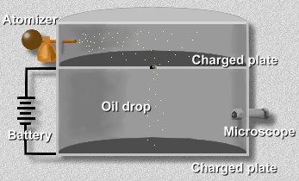

Small oil droplets were forced through an atomizer causing them to become charged. The oil droplets then fall through a small hole where they move between two metal plates.

A particular oil droplet is located and is held stationary by applying a p.d. between the two plates (negative charge on the bottom plate). The p.d. is noted and the droplet is allowed to free-fall through a measured distance and the time taken to fall is noted.

Using Stoke’s law: F = 6πηrv

The weight of the droplet can be found and using the relationship:

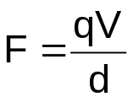

Where F is the weight of the droplet, the charge of an individual droplet can be found.

Milikan found that all droplets had an integer multiple of a fundamental charge of
1.6x10⁻¹⁹C.
Wave-Particle Duality
History

Newton:

- Thought that light consisted of particles called “corpuscles”.
- Corpuscles travel faster in more dense materials.
- Reflection is easy to explain.
- Refraction more difficult (he said that light was attracted to more dense materials).
- Interference and diffraction can’t be explained. (Young’s slits, for example, would result in two bright fringes only)

Huygens:

- Thought that light was a wave.
- Light waves travel slower in more dense material.
- Light waves are longitudinal (so can’t explain polarization).
- Refraction can be explained (but speed of light can’t be measured).
- Interference can be explained.

However, Newton was much more famous and had such a great intellectual stature compared to Huygens. Therefore, Huygens theory was ignored for over a century until diffraction was discovered in the early 19th century.

A General Overview

We have seen that the quantum picture of radiation is used to explain the photoelectric effect. While the classical wave picture fails to do so. Similarly, classical wave theory provides the basics for complete explanation of phenomena such as polarisation, diffraction and interference, while the quantum theory, at least at first glance, presents difficulties in these fields. In the diffraction at a slit, for example, light passing through the slit is found to emerge at some angles but to be entirely absent at others.

It seems that the wave picture of radiation gives an explanation of some effects, while the quantum picture explains others. It is reasonable to suppose that there should be no actual change in the nature of light, or any EM radiation, from one phenomenon to another so that the wave and quantum viewpoints must be two incomplete pictures of the same thing.

For some time after the development of the quantum theory with its outstanding initial success in describing the photoelectric effect and subsequent triumph in explaining the production of EM radiation by atoms, it was necessary to view the two theories, wave and quantum, as distinct entities. The one or the other picture being used accordingly to the problem involved. It seemed that light was emitted and absorbed as quanta, but travelled as waves.

This point of view cannot be challenged experimentally but it is philosophically objectionable to have to think of one quantity as appearing in two different forms.

This reason for the difficulty lies in trying to form mechanical pictures of a phenomenon which can only be observed by its effects.

Thus, quantum and wave pictures of radiation are each only one aspect of the full picture. Both are needed to explain all the observed facts. There is a link between the two apparently diverging viewpoints, and the most satisfactory way to clarify the relationship between the two pictures is to think in terms of a specific situation. Thus, in considering the formation of a diffraction pattern, it can be explained both in terms of waves (Dark bands correspond to minimum amplitude and light bands to maximum amplitude) and particles (The intensity at any given point in the pattern may be equated with the probability that a given photon will reach that point).

When quantum ideas are used, the history of an individual photon is traced, whereas when wave ideas are used the problem concerns the distribution of a large number of quanta through the region under consideration, i.e. the quantum theory applies to the individual event, the wave theory to a statistical average over vast numbers of quanta.

This wave-particle duality led de Broglie to suggest, in 1923, that matter might also exhibit this duality and have both wave and particle properties, just like EM radiation. His ideas can be expressed quantitatively by first considering radiation:

A photon of frequency f and wavelength λ has, according to quantum theory, energy:

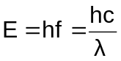
Where h is Planck’s constant and c is the speed of light.

By Einstein’s energy / mass relation, the equivalent mass of the photon is given by:

E = mc²

Equating the two:
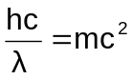 or 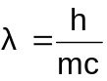
By analogy, de Broglie suggested that a particle of mass m, moving with speed, v behaves in some ways like waves of wavelength .
Electrons accelerated through a p.d. of ∼100V should be associated with matter waves having a wavelength of the order of 10⁻¹⁰m. This is about the same as for X-rays and it was suggested that the conditions required to reveal the wave nature of X-rays might also lead to the discovery of “electron waves”.

Within a few years, experimental evidence proved that moving particles of matter had wave-like properties associated with them. Hence, interference and diffraction patterns can be obtained with electrons, and the electron microscope is a very important practical application of the wave properties of the electron.
Diffraction with Particles!
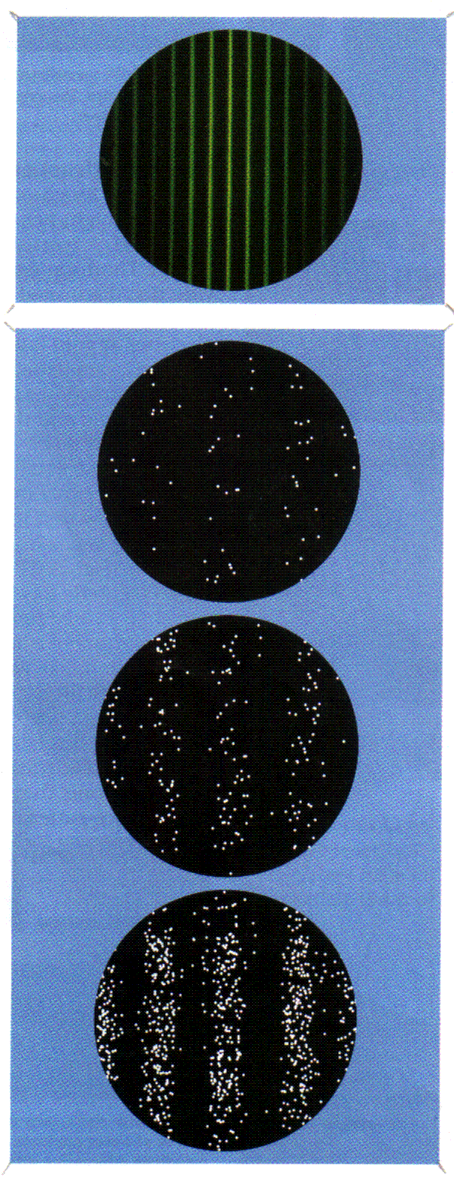

When light is diffracted through two slits, alternating patterns of high and low intensity are produced. Electrons behave in the same way when they pass through a double slit.

Electron diffraction

The electrons arrive one by one, but the picture builds up into familiar bands of high and low intensity.
Electrons and Electron Micoscopes

It was known that when a photon collides with an electron that the electron recoils. This establishes the fact that photons have momentum! Waves can exhibit particle properties!

de Broglie was the first to suggest that if waves could exhibit particle properties it would seem obvious that particles could exhibit wave properties and he suggested that particles had a wavelength associated with them given by:

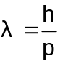
where h is Planck’s constant and p is the particle’s momentum.

The momentum of an electron is related to its speed, which in turn depends on the energy used to accelerate it in the first place. The energy, E, given to an electron, charge, e, by the electron gun with voltage, V, is given by: E = e × V. This can be equated to the electron’s final kinetic energy:

½mv² = eV mv² = 2eV m²v² = 2meV

Momentum is mass × velocity (p = mv) so:

p² = 2meV

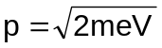

We can substitute this into the de Broglie relationship (λ = h/p),

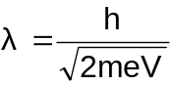

Diffraction is a natural limit on the resolution of an object. To resolve (distinguish between) objects in an image, the waves used to make the image need to have a wavelength of the same order of size (or smaller) than the objects. The wavelength of visible light is approx. 5 × 10⁻⁷m. This means that a pair of objects less than about a millionth of a metre apart will blur into one no matter how many times their image is multiplied.

Using the above relationship calculate the wavelength associated with an electron that has been accelerated through a p.d. of 100V. Compare the order of magnitude difference with the wavelength of light and a comparison with atomic sizes.

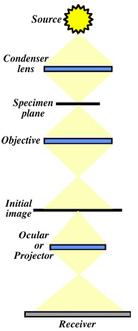
The principle behind both light and electron microscopes is similar, see diagram to the right:

Radiation from the source is focussed by the condenser lens very near to the specimen plane.

The specimen is placed on a stage that may be moved perpendicularly to the radiation.

The objective lens focusses the radiation through the specimen to form an initial image.

This is then magnified and refocused by a group of lenses (the projector in the electron microscope or the ocular in the light microscope) to form an image that will be finally placed on a receiver (i.e, photographic emulsion, digital imaging system).

The path followed by the electrons in the electron microscope is symmetrical about the straight through position of the magnetic lenses. The diagram below illustrates a markscheme answer to a question asking you to sketch the path of an electron through the two lenses:
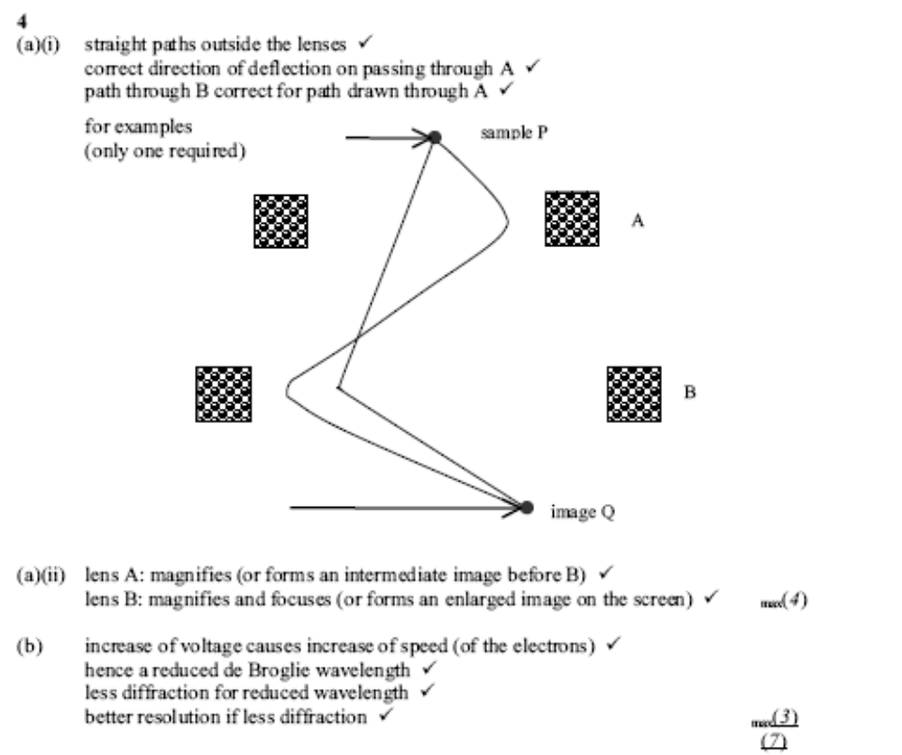

Scanning Tunnelling Electron Microscope

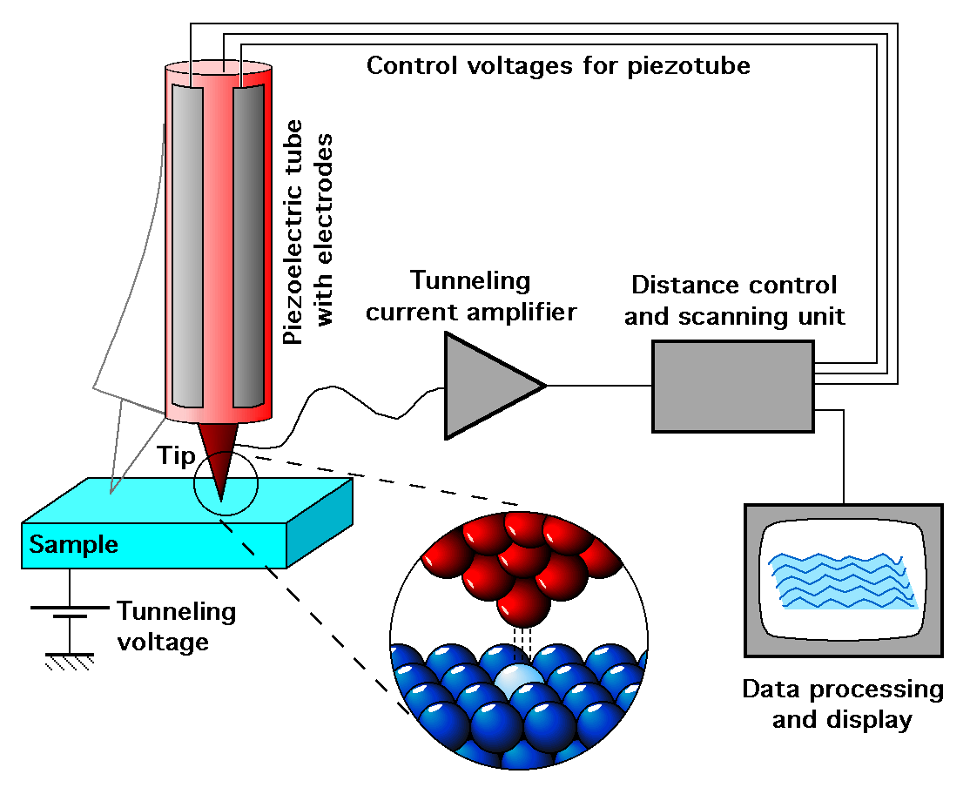

- Electrons have a wave-like nature
- There is a small probability that an electron can tunnel across the gap
- The transfer is from – to + only as the electrons are repelled by the –ve electrode
- The tunneling current is inversely proportional to the distance of the probe from the surface of the sample
- This distance is controlled to give an image of the surface
Theories of Light

The lenses of a telescope separate one colour of light from another, so that a star can appear bluish or reddish, depending on the adjustment of the telescope. This effect is called chromatic aberration and it is an irritation to astronomers.
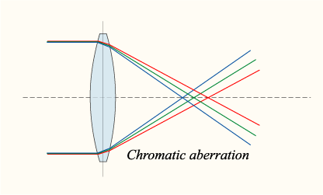
Isaac Newton tried to develop lenses that got rid of this chromatic aberration, but he failed. In the process he discovered that white light is an even mixture of all colours. A prism and a stream of white light were all that was needed to demonstrate the splitting, or “dispersion” of light into colours. People found Newton’s idea that colours are components of white light to be convincing. So when he went on to create explanations of the behaviour of light in terms of assorted particles, people were inclined to be convinced again.

A prism, Newton said, exerts different forces on different particles of light, and separates them. Refraction, he said, happened when the particles changed speed, speeding up, for example, when they pass from air into glass or water. (See below)
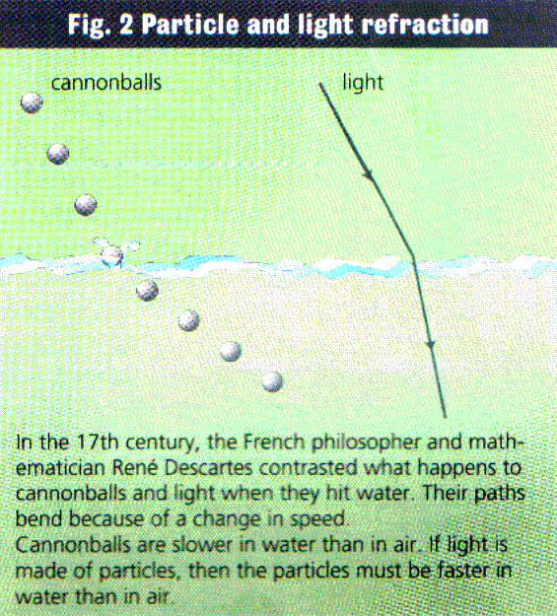
A Dutch scientist, Christiaan Huygens (1629-1695), had a completely different way of explaining the behaviour of light. He thought of light as a wave in the form of a series of irregular movements, and he used this to provide a neat explanation of refraction.
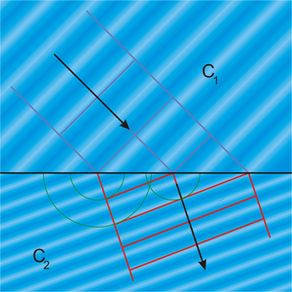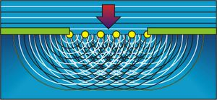

A major difference with Newton’s ideas was that, to explain refraction, Huygens’ impulses must travel more slowly in glass (and water) than in air.

But Huygens had no way of explaining how his impulses might explain different colours (his impulses had no regular frequency) and the dispersion of white light. Newton’s theory was also able to explain the phenomenon of polarisation. Huygens’ theory could not because he had only imagined longitudinal impulses. So the particle theory was largely favoured and remained so for more than a hundred years.

It was only around 1850 that it was demonstrated that light was slower in water than in air. This finally buried any notion that light could be due to simple particles.

Young’s Two Slit Experiment
One of the first demonstrations of the interference of light waves was by Young in 1801. He placed a source of monochromatic light in front of a narrow slit, and arranged two very narrow slits close to each other, in front of the first slit. Young then saw bright and dark bands on a screen in front of the two slits.
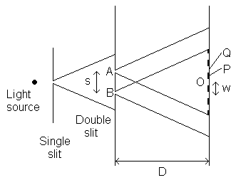
The first slit is required so that the source of light can be considered to be a point source, the two slits are required so that a path difference can be set up.
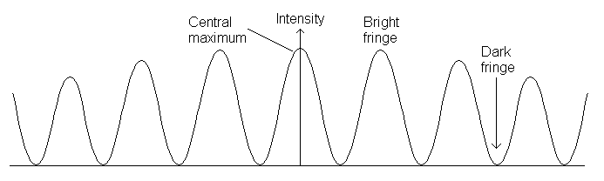
Q P O
The light coming from the two slits have the same frequency and are always in phase with each other since the two light beams originate from the same source.Interference occurs where the two light beams overlap. As AO = OB a bright band is obtained at O. At a point close to O, such that 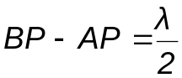 where λ is the wavelength of the light from the source, a dark band is obtained. At a point Q such that BQ – AQ = λ, a bright band is obtained; and so on for either side of O. Young demonstrated that the bands or fringes were due to interference by covering A or B – the fringes disappeared.
The distance between two successive maxima w can be found using the equation:
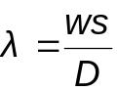
where λ is the wavelength of the light used, s the separation of the two slits and D the distance from the slits to the screen.

Young’s Slits Significance:

The resulting pattern of the double slit experiment and that of Newton’s rings (see below) were both caused by constructive and destructive interference.

There is nothing in particle theory to explain this phenomenon, but wave theory does explain this. Huygens’ wave theory allows for constructive and destructive interference.

Newton’ Rings:

A series of circular bright and dark bands which appear about the point of contact between a glass plate and a convex lens which is pressed against it and illuminated with monochromatic light.

The Electromagnetic Spectrum

Electromagnetic waves are self-supporting – the electric field induces the magnetic field, and the magnetic field induces the electric field. Since they mutually support each other, the wave requires no medium for its propagation, and it readily travels through a vacuum.

The electromagnetic spectrum covers the full wavelength range of electromagnetic waves from gamma radiation and X-radiation at the short-wavelength end of the spectrum to radio and TV waves at the long-wavelength end.

It is convenient to divide the spectrum into bands.

The main bands of the electromagnetic spectrum in order of increasing wavelength are: gamma radiation and x-radiation, ultraviolet radiation, visible light, infrared radiation, microwave radiation, radio and TV waves.

All electromagnetic waves share the following characteristics:

1. The same speed of propagation c = 3.00 × 10⁸ ms⁻¹ through empty space.

2. All electromagnetic waves are transverse waves and can therefore be polarised.

3. Electromagnetic energy is emitted and absorbed in quanta of energy, called photons. The energy, E, of a photon of frequency f is E = hf where h is the Planck constant.

4. The wavelength λ of an electromagnetic wave of frequency f is given by 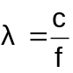
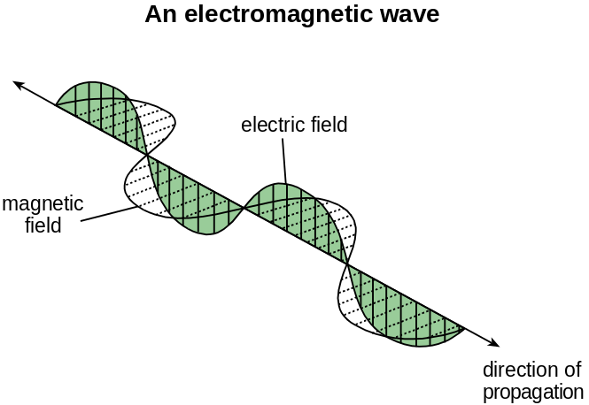

An electromagnetic wave consists of oscillating electric and magnetic fields at right angles to each other and to the direction of propagation of the wave. The theory of electromagnetic waves was established by James Clerk Maxwell in 1862, years before the artificial generation of radio waves.

Maxwell showed that the speed of electromagnetic waves in free space 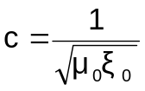, where ε₀ relates to the electric field strength due to a charged object in free space and μ₀ relates to the magnetic flux density due to a current carrying wire in free space. Substituting numerical values for μ₀ and ξ₀ into this equation gives the same (measured) value as the speed of light in free space. This calculation convinced Maxwell and his contemporaries that light is an electromagnetic wave and that a wide spectrum of electromagnetic waves beyond the visible spectrum must exist.

Discoveries of the different parts:

Infrared and ultraviolet radiation were discovered by Sir John Herschel in the early nineteenth century. Herschel discovered infrared radiation by detecting an increase of temperature in a liquid-in-glass thermometer with a blackened bulb placed beyond the red end of the visible spectrum. He also discovered ultraviolet radiation when he found that fluorescent paper shone brightly when placed beyond the violet end of the visible spectrum.

X-radiation was not discovered until 1895 when Wilhelm Röntgen showed that radiation was emitted by a high-voltage discharge tube which caused fluorescence in certain materials. He showed that this radiation could not be stopped by thin metal plates.

Radio waves were discovered in 1887 when Heinrich Hertz found out how to produce and detect them*. Hertz measured the wavelength and frequency of the radio waves produced and showed that the speed of the radio waves (= wavelength × frequency) was the same as the speed of light.

The discovery of gamma radiation was made as a result of investigations of radioactive substances carried out by Paul Villard in 1900.

Summary of the main bands of the electromagnetic spectrum

Waveband | Wavelength Range | Typical Source | Detector | Application
Gamma radiation | <1nm | Radioactive decay of a nucleus | Geiger counter, film, ionisation chamber | Medical imaging, therapy, sterilisation of medical instruments
X-rays | <1nm | Inner shell atomic electron transitions | As above | X ray imaging in medicine and dentistry
Ultra Violet | 1 - 400nm | Atomic electron transitions | Photocell, film | Sun bed, security marking
Visible | 400 - 700nm | Outer shell atomic electron transitions | Eye, film, CCD, photocell. | Camera, seeing
Infra Red | 700nm - 1mm | Vibrations of atoms and molecules | Thermopile, solid state detectors | Thermography in medicine, fibre optic communications
Microwave | 1mm – 0.1m | Electrons in resonant cavities (e.g. magnetron valve) | Microwave diode | Line of sight communications, satellite communications
Radio and TV | > 0.1m | Electrons accelerated and decelerated in an aerial | Aerial | Communications

*See later for production and detection of radio waves.
Radio Waves

Radio and TV waves are used for communications, for medical imaging and for navigational purposes.

Radio waves are electromagnetic waves in the wavelength range from about 0.1 m upwards, corresponding to frequencies up to about 3000 MHz.

Radio waves can be produced by making electrons oscillate to and fro along an aerial. An alternating potential is applied to the aerial at the intended radio frequency, making the electrons accelerate and decelerate in the aerial. As a result, radio waves radiate from the aerial at the same frequency as the alternating potential. The use of radio and TV transmitters is carefully controlled by means of frequency channels to ensure radio and TV receivers do not pick up unwanted signals. Without such legal controls, radio and TV communications would be impossible.

The radio frequency part of the electromagnetic spectrum is subdivided into frequency bands, each used for a specific form of radio communication according to its characteristics.

For example the long-wave (LW) band covering frequencies up to 300 kHz is used for international AM broadcasting as well as for maritime communications. Note that the term 'radio wave' covers all electromagnetic waves at frequencies below about 3000 MHz, including TV carrier waves.

Summary of the main wave bands:

Waveband | Frequency Range | Uses
Long wave (LW) | Up to 300kHz | International AM
Medium wave (MW) | 300kHz – 3MHz | AM Radio
High frequency (HF) | 3 – 30MHz | AM Radio
Very High Frequency (VHF) | 30 – 300MHz | FM Radio
Ultra High Frequency (UHF) | 300 – 3000MHz | TV Broadcasting, mobile phones.

Radio waves were first produced experimentally in 1887 when Heinrich Hertz discovered that sparks produced by an induction coil connected to a pair of metal plates created tiny sparks between two small adjacent metal spheres attached to the plates.
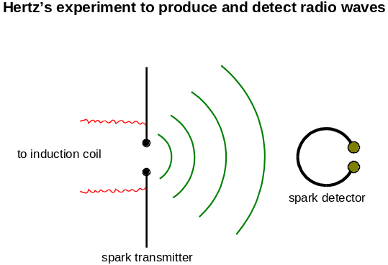

The invention of the diode valve by J A Fleming in 1905 provided a more sensitive method of detecting the tiny signals induced by radio waves in receiver aerials. The diode allows current through in one direction only and therefore converts alternating to direct current. By connecting the diode and a pair of headphones to the aerial, a Morse-code signal could be detected using the headphones. Further work by Lee de Forest led to the invention of the triode valve in 1907 for amplifying small signals and also to generate alternating potentials at radio frequencies.

The first radio stations were in operation by the 1920s, broadcasting at frequencies of the order of 100 to 200 kHz to local receivers.

Higher frequency radio waves up to about 30 MHz are reflected from conducting layers of ionised gas in the upper atmosphere. This is why local broadcasts from distant countries can sometimes be detected in summer when this effect is strongest. Below 30 MHz, radio waves from a ground transmitter travel round the Earth as result of multiple reflections between the ground and the conducting layers in the upper atmosphere. Above 30 MHz, radio waves pass straight through the atmosphere and into space.

Information is carried by radio waves using amplitude modulation (AM) at frequencies up to about 30 MHz. The bandwidth for audio signals carried by AM transmission is restricted to 4 kHz to provide discrete radio channels for broadcast and emergency services. Therefore, audio frequencies above 4 kHz are not transmitted which means that AM radio programmes are lower in quality and suffer more distortion than frequency modulation (FM) transmission. Frequency modulation requires a wider bandwidth so FM transmission requires carrier frequencies from 30 to 300 MHz. As analogue TV channels are each allocated an 8 MHz bandwidth to carry the video and audio signal, TV carrier waves are in the waveband from 300 to 3000 MHz. Digital TV channels require greater bandwidths.

Radio telescopes are able to map out sources of radio waves in space. A large single-dish reflector is designed to scan areas of the sky and focus radio waves onto an aerial to enable an image to be formed of any radio sources in the scanned area. The wider the dish, the greater the resolving power of the telescope.

The Photoelectric Effect

The first observations were made by Hertz in 1887. The effect consists of the emission of electrons from the surface of a metal when electromagnetic waves of high enough frequency fall on the surface of a piece of metal.

The Laws of Photoelectric Emission

- When the incident light is monochromatic the number of electrons emitted per second is proportional to the light intensity. Such an emission occurs effectively instantaneously.

- The kinetic energy of the emitted electrons varies from 0 to a maximum value. This definite maximum and the electron energy distribution both depend only on the frequency of the light, and not on its intensity.

- Electrons are not emitted when the light has a frequency lower than a certain threshold value, f₀. The value of f₀ varies from metal to metal.

Difficulties of a wave theory:

If light is considered to be wholly wave-like, the area of the metal that the light is shining on should receive a uniform distribution of energy.

In that case we can’t explain why:

- The effect is only observed when the light frequency reaches a value f₀, regardless of its intensity.
- The electron emission is instantaneous even if very faint light is used, a time delay of 10³s would be expected.
- The maximum speed of the emitted electrons is independent of the intensity of the incident radiation.
Einstein’s Photoelectric Equation

A photon has energy E associated with it such that E = hf, where h is Planck’s constant and f is the photon’s frequency.

The energy needed to completely remove an electron from the surface of a metal is called the work function, ϕ.

Photoemission only occurs when the photon’s energy is equal to or greater than the work function.
E > ϕ hf > ϕ

Photoemission only occurs when f reaches a certain value, called the threshold frequency, f₀.
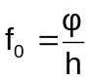

When f is larger than f₀, the photon carries more energy than is required to liberate an electron. This “extra” energy is converted into the kinetic energy of the emitted electron.

hf = ϕ + E_{k}

(Energy of photon = Work Function + Kinetic energy of electron)

The kinetic energy in the above equation is the maximum kinetic energy the electron can have. If it was emitted from somewhere other than the surface of the metal this value may be less.

- Monochromatic light of wavelength 450nm falls on the cathode of a photocell at a rate of 25μW. Only 10% of the photons produce an electron and these electrons produce a current, I, in an external circuit.

The following data is needed in this question.

Planck constant = 6.63 × 10⁻³⁴ Js
Speed of light in vacuo = 3.00 × 10⁸ ms⁻¹
Charge of an electron = 1.6 × 10⁻¹⁹C

- (a) Calculate: (i) The energy of one photon in J.
- (ii) The no. of photons falling on the cathode per second.
- The current, I.
(b) The same amount of energy per second falls on the cathode in the form of light of wavelength 600nm. The work function of the material of the cathode is 3.0 × 10⁻¹⁹J. Show that a photoelectric current will flow.

Michelson-Morley Interferometer

As a result of Michelson's efforts in 1879, the speed of light was known to be 186,350 miles per second.
Still, this did not really clarify the nature of light. Two hundred years earlier, Newton had suggested that light consists of tiny energized particles that bounce off objects and are detected by our eyes and Robert Hooke, on the other hand, thought that light must be a kind of wave, like sound.
At last, different scientific considerations, led to the notion that light is a wave. When a sound wave propagates, it needs some medium to pass through, like air, water, metal, etc. If light is a wave like sound then what medium it passes through?

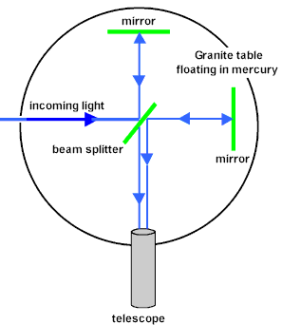
It was natural to suppose that light must be moving through some mysterious material, which was called the ether (aether), surrounding and permeating everything. This ether must also fill all of space, out to the stars, because we can see them, so the medium must be there to carry the light. And because the Earth's rotation on its axis and its movement around the sun this ether could be described as a ghostly wind blowing through the Earth.
Detecting the motion of the Earth through the ether wind was the next challenge Michelson set himself after his triumph in measuring the speed of light so accurately. For this he teamed up with Morley, a chemistry professor, that was an experienced experimenter.

For their experiment, Michelson and Morley build an interferometer instrument that was able to detect light waves interference effects.

The scheme of the experiment is as follows: a pulse of light is directed at an angle of 45 degrees at a half-silvered, half transparent mirror, so that half the pulse goes on through the glass, half is reflected. They both go on to distant mirrors (that are located at equal distance from the half-silvered mirror), which reflect them back to the half-silvered mirror. At this point, they are again half reflected and half transmitted, but a telescope is placed behind the half-silvered mirror as shown in the figure so that half of each half-pulse will arrive in this telescope. Now, if there is an ether wind blowing through the Earth, someone looking through the telescope should see the halves of the two half-pulses to arrive at slightly different times, since both light beams travel the same distance and the one that would have gone upstream and back is more inhibited than the one gone across the stream. It is possible to demonstrate by simple calculations why this difference occurs.
To the researchers surprise, any interference effects were not seen through the telescope.
The only possible conclusion from this series of very difficult experiments was that the whole concept of an all-pervading ether was wrong from the start.
Einstein’s Theory of Special Relativity

Inertial Reference Frames

If you are in a school laboratory you will measure the positions and motion of things relative to the laboratory. If you were on a train or in an aircraft you would measure them compared to a reference frame that is moving with the train or aircraft.

Reference frames that move at constant velocity with no acceleration are called inertial reference frames (since any free object moves like this because of its own inertia).

Einstein’s Postulates of Special Relativity

- Physical laws have the same form in all inertial reference frames.

2. The speed of light in free space is invariant.

These postulates have several consequences:

- There is no experiment you could carry out to tell whether you are moving or not.

- If the speed of light is the same in all directions the “ether” has no effect, if it has no effect it serves no purpose. Special relativity killed off the “ether theory”.

- It is impossible to travel at the speed of light since as no matter how fast you travel the speed of light relative to you remains constant. However much you accelerate something, it can never quite reach the speed of light. Nothing can travel faster than light either.

Formula for time dilation, t₀ is “proper” time: 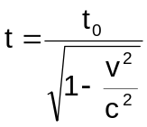

Formula for length contraction, L₀ is “proper” length: 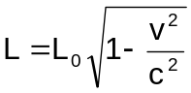

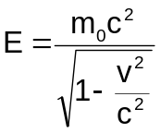
The total relativistic energy (both rest mass
energy and kinetic energy) of a free particle is:

The kinetic energy of a relativistic particle is: E = (m-m₀)c²

The relativistic mass m of a particle, m₀ is proper mass: 

