Module 1: Particles and Quantum Phenomena

Constituents of the Atom

Central nucleus: Tiny and massive containing protons and neutrons.

Electrons: Orbiting the nucleus.

Particle | Relative mass | Mass (kg) | Relative charge | Charge (Coulombs)
Proton | 1 | 1.673×10⁻²⁷ | +1 | +1.6×10⁻¹⁹
Neutron | 1 | 1.675×10⁻²⁷ | 0 | 0
Electron | 0 | 9.11×10⁻³¹ | -1 | -1.6×10⁻¹⁹

The Nuclear Model of the Atom

The nucleon number, A, is the total number of protons and neutrons in the nucleus.
Chemists call this the Atomic mass number.

The proton number, Z, is the number of protons (and the number of electrons in a neutral atom). Chemists call this the Atomic number.

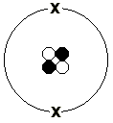
Consider the helium atom:

Overall charge: 0

The notation for such an atom is 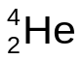, the nucleon no. is 4 and the proton no. is 2. The no. of electrons is also 2 as this atom is neutral; if an atom loses an electron we say it has been ionized, it is an ion.

Specific Charge

This is the charge per unit mass or the charge : mass ratio. It is calculated by dividing the charge (in Coulombs) of a particle by its mass (in kg), it can also be applied to nuclei and ions.

The table below includes the specific charge of the constituents of the atom:

Particle | Charge (Coulombs) | Mass (kg) | Specific Charge (Ckg⁻¹)
Proton | +1.6×10⁻¹⁹ | 1.673×10⁻²⁷ | 9.56x10⁷
Neutron | 0 | 1.675×10⁻²⁷ | 0
Electron | -1.6×10⁻¹⁹ | 9.11×10⁻³¹ | (-)1.76x10¹¹
To calculate the specific charge of a nucleus, you need to calculate the charge of the nucleus and its mass. The worked example below is for a uranium nucleus:

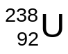 Relative charge = +92, charge in C = 92 x 1.6x10⁻¹⁹C = 1.47x10⁻¹⁷C

Relative mass = 238, mass in kg = 238 x 1.67x10⁻²⁷kg = 3.97x10⁻²⁵kg

Specific charge = 3.70x10⁷Ckg⁻¹

Now calculate the specific charge for a Carbon nucleus: 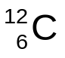

An ion is an atom that has had one or more electrons removed. To calculate the specific charge of an ion you only need to consider the charge of the ion as a whole, for example:

Calculate the specific charge of a 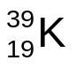ion that has a charge of +3.2x10⁻¹⁹C.

Charge in C = 3.2x10⁻¹⁹C

Relative mass = 39, mass in kg = 39 x 1.67x10⁻²⁷kg = 6.51x10⁻²⁶kg

Specific charge = 4.92x10⁶Ckg⁻¹

The ion has a charge of +3.2x10⁻¹⁹C as it has lost two electrons.

Now calculate the specific charge of a 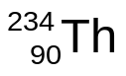ion that has lost one electron.

Isotopes

The proton number determines which element we are dealing with.

The number of electrons determines an element’s chemical properties.

The number of neutrons is variable, however.

An element with a different number of neutrons than that of the most common form is called an isotope.

Question:
Iodine-131 was the first radioisotope used in medicine. It can be written as 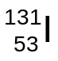. How many protons, neutrons and electrons does it have?

The 4 Fundamental Forces (or Interactions)

Consider the He atom:

Overall charge: 0

Positive charges cause repulsion, why then does the nucleus not just break up?

The “strong interaction” holds it together, which is one of the four fundamental forces:

- The gravitational interaction. Gravity attracts all matter, but is too weak to have significant effects at subatomic scales.

- The electromagnetic interaction. This plays an important role in the forces between charged particles and is responsible for the phenomenon of electromagnetism.

- The strong interaction. This force holds atomic nuclei together and stops them coming apart due to the mutual repulsion of the protons.

- The weak interaction. This is a force that is involved in nuclear beta decay and other radioactive processes. All hadrons and leptons experience the weak interaction (see later).

Strength and Range of Fundamental Forces

Force | Acts on… | Strength* (N) | Range (m)
Gravitational | All masses | 10⁻³⁴ | ∞
Weak | All hadrons and leptons | 10⁻² | <10⁻¹⁷
EM | Electric charges | 10² | ∞
Strong | Nuclear particles | 10⁴ | 10⁻¹⁵

*The strength listed is the force (N) between 2 protons separated by a distance equal to their diameter, 2×10⁻¹⁵m.
The Strong Interaction

Why don’t nuclei collapse in on themselves?

The strong interaction is attractive up to about 3fm (3x10⁻¹⁵m). At separations less than 0.5fm the force is strongly repulsive.
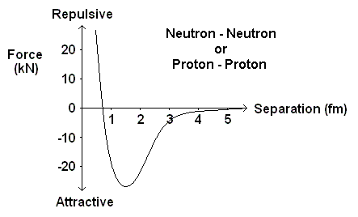

Nuclei contain neutrons to reduce the magnitude of the electrostatic repulsion between protons. The neutrons exert a strong nuclear attraction on both protons and neutrons.

The Existence of the Nucleus

Thomson’s “Plum Pudding” model of the atom consisted of a positively charged dough with negative electrons embedded in the dough.

Alpha (α) Particle Scattering:

Gold foil is bombarded with high speed (10⁷ms⁻¹) α-particles.

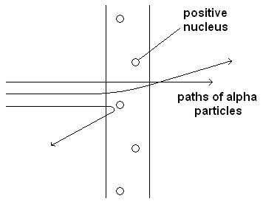
The momentum of an α-particle is relatively large and if the positive charge of the dough was as spread out as Thomson suggested, the alpha particle would not be deflected through very large angles.
Radioactive Decay and the Existence of the Neutrino

In alpha (α) decay, a heavy nucleus releases an alpha particle (a helium nucleus) and the nucleus recoils.
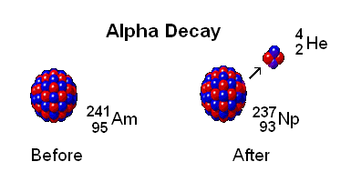
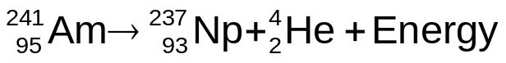

General symbol equation for alpha particle emission:
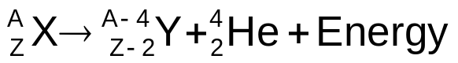

For a particular element, an alpha particle will be released with the same kinetic energy and will penetrate the same distance in a given material.

Sometimes, the alpha particle doesn’t carry away all the available energy and the daughter atom is left in one of several possible energetic or excited states.

A gamma ray photon is then released.

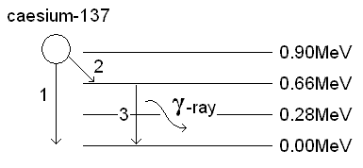
1. Decay to the ground state
2. Decay to an excited state
3. Nucleus decays to ground state emitting a γ-ray photon.
In beta (β) decay the beta particle (an electron) is released with a continuous range of energies.
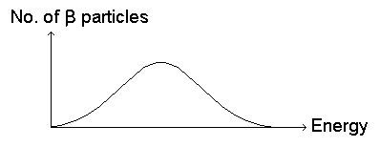
Alpha (α) particles are released with discrete energies.

It is possible to calculate how much energy a β particle should have that is released from a particular element.

In all cases the beta particle has less energy than it should have.

Conservation of energy has been violated!!!

Wolfgang Pauli in 1931 suggested this explanation:

“An extra particle is ejected from the nucleus which can have a range of energies but has a zero rest mass.”

He named this particle the neutrino, which means little neutral one.

The sum of the energy of the electron and the neutrino is a constant value for a particular element.

The neutrino is a neutral, fundamental particle of zero rest mass. The symbol for a neutrino is the Greek letter, nu (ν).

The neutrino was only detected experimentally in 1956. Billions of them pass through your body every second with no effect.

They are unaffected by both electrical and gravitational fields and interact very weakly with matter and only through the weak interaction.

Antineutrinos are produced in beta decay, the difference between a neutrino and an antineutrino is the direction of its spin.

Spin is analogous with the concept of rotation in classical dynamics.

Carbon-14 is a β⁻ particle emitter and a symbol equation for this decay is:
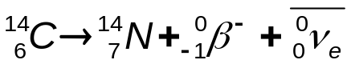
The general symbol equation for β⁻ decay is:
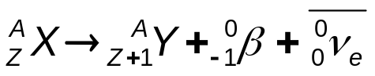
Particles and Antiparticles

Every particle has an antiparticle, which is equal in mass but has the opposite set of quantum properties (like charge).

The electron’s antiparticle is the positron.

When particles and antiparticles meet they annihilate and their mass is converted into pure energy!

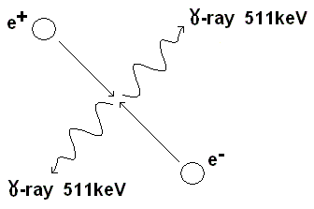

Particle energies are usually give in electron-volts, the electron-volt is a very small unit of energy,

1eV = 1.6×10⁻¹⁹J

The electron-volt is equal to the kinetic energy gained by an electron that is accelerated by a p.d. of 1Volt.
From current electricity: 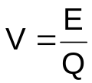

For an e⁻ of charge Q, p.d. 1Volt:

E = QV = 1.6×10⁻¹⁹ × 1 = 1.6×10⁻¹⁹J

Hence 1eV = 1.6×10⁻¹⁹J

Question:

An electron is accelerated from rest through a p.d. of 1000V. What is its:
- kinetic energy in J.
- kinetic energy in eV.
- speed in m/s.

Mass of an electron = 9.11×10⁻³¹kg.

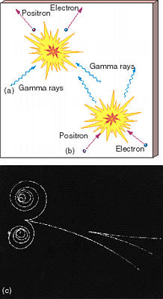
Pair Production

Annihilation is the conversion of matter to energy.

Pair production is the conversion of energy to matter.

Particles can be created by colliding particles into each other or into fixed targets at very, very high speeds.

Particle accelerators like a synchrotron are used to do this:

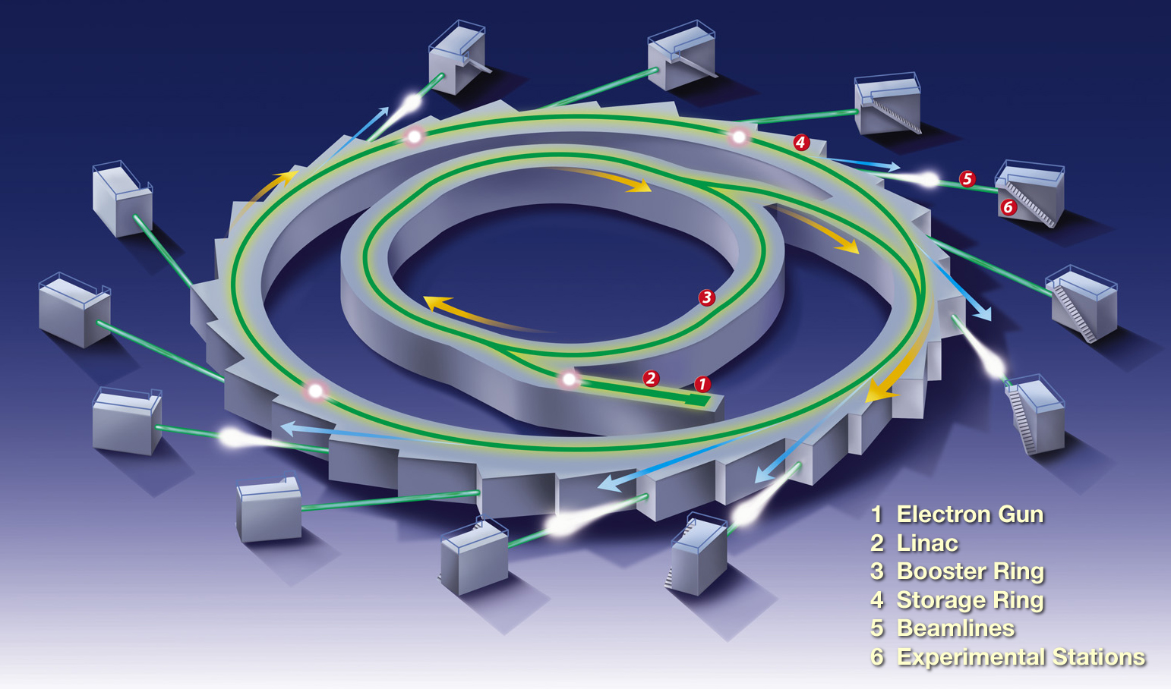
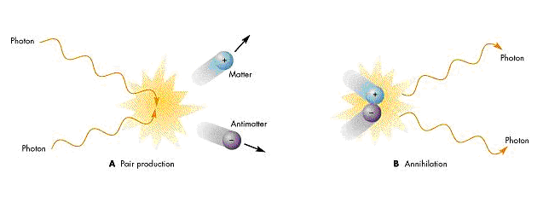

Anti-nucleons can be made in particle accelerators by smashing protons into each other.

Approximate energy of protons = 6MeV

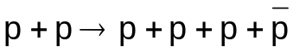

A proton and an antiproton have been produced from the kinetic energy of the two protons.

Pair Production and Planck’s Constant

Particles of energy ΔE can exist for a time Δt, as long as the product of the two quantities doesn’t exceed Planck’s constant, h (6.6×10⁻³⁴Js).

ΔE × Δt < h

Particles can “pop” in and out of existence in this way.

Comparison of particles with their respective antiparticles:

Particle | Charge (C) | Rest Mass (kg) | Rest Energy (MeV)
Proton | +1.6×10⁻¹⁹ | 1.673×10⁻²⁷ | 938
Neutron | 0 | 1.675×10⁻²⁷ | 938
Electron | -1.6×10⁻¹⁹ | 9.11×10⁻³¹ | 0.511
Neutrino | 0 | 0 ? | 0 ?

An antiparticle’s charge is opposite to the particle’s charge but the rest mass and rest energy are identical.

The Photon Model of Electromagnetic Radiation

There are many situations that suggest that electromagnetic radiation is wave-like in nature: refraction, diffraction, interference. There are, however, other situations where electromagnetic radiation behaves like a particle; the photoelectric effect, for example.

Einstein discovered that electromagnetic radiation is quantized into “wave packets” of energy called photons.

Each photon has a discrete amount of energy, E, that is dependent only on the photon’s frequency.

Energy (J) = Planck’s constant (Js) × frequency (Hz)

Or E = hf

h, Planck’s constant = 6.63×10⁻³⁴Js
Exchange Particles and Feynmann Diagrams

Virtual particles are exchanged when forces are experienced between particles. The virtual particle travels between the real particles affecting their motion in some way.

Remember particles can exist for a short time provided the product of the time for which they exist and their energy does not exceed Planck’s constant. (ΔE × Δt < h)

This has to do with Heisenberg’s uncertainty principle.

Exchange particles that are transferred between fundamental particles are called gauge bosons.

Feynmann Diagrams

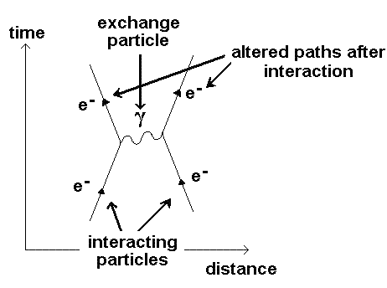

The Electromagnetic (EM) Interaction:

Mediated by the photon, γ, which is neutral and has a zero rest-mass. It is its own antiparticle.
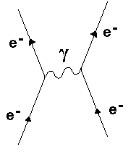

A photon being exchanged between two electrons.

The Weak Interaction: (v.short range ~10⁻¹⁸m)

Mediated by three gauge bosons: W⁺, W⁻. The W⁺ and the W⁻ are antiparticles of each other.
These are also known as intermediate vector bosons.

Beta minus (β⁻) decay:

This occurs in neutron rich nuclei.
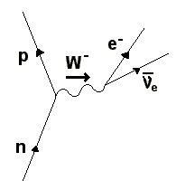

A neutron decays into a proton emitting a W⁻ boson.

The W⁻ boson then decays into an electron and an anti electron neutrino.

Beta plus (β⁺) decay:

This occurs in proton rich nuclei.
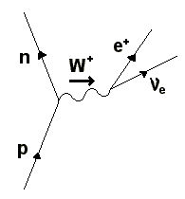

A proton decays into a neutron emitting a W⁺ boson.

The W⁺ boson then decays into a positron and an electron neutrino.

The proton is the only stable baryon into which other baryons eventually decay. The above decay only happens within the nucleus.

Electron Capture:
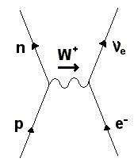
An atomic electron is absorbed by a proton which decays into a neutron and an electron neutrino.

This decay is mediated by a W⁺ boson.

Electron-Proton Collision:
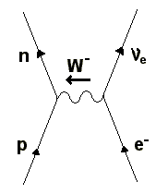
An electron collides with a proton which decays into a neutron and an electron neutrino.

This decay is mediated by a W⁻ boson.

Classification of Particles

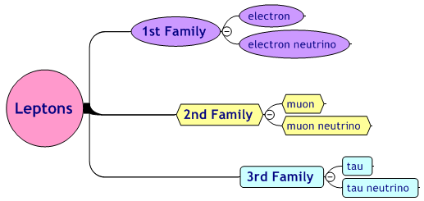
Lepton Families:

Electron = e⁻
Electron neutrino = ν_{e}

Muon = μ⁻
Muon neutrino = ν_{μ}

Tau = τ⁻
Tau neutrino = ν_{τ}

There are 12 members of the lepton family, all of which are fundamental particles. The other 6 leptons are the antiparticles of the particles above.

All the above leptons have a Lepton Number of +1 and all the antiparticles have a Lepton Number of -1.

Leptons are subject to the weak interaction.

Antiparticles are written as for the antiproton, for example.
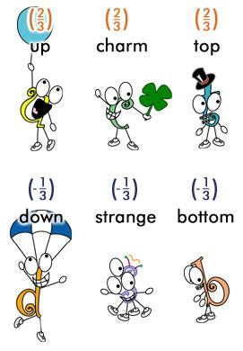
Quarks:

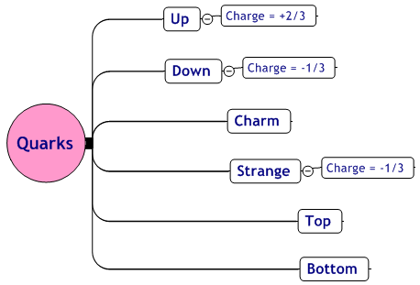

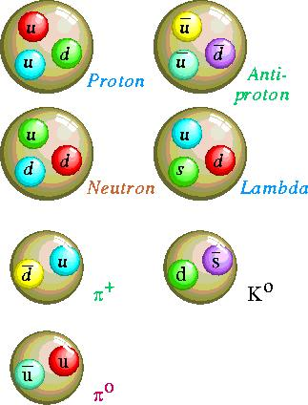

Hadrons:

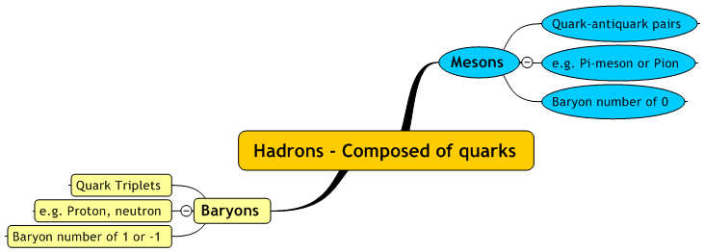

Hadrons are subject to the strong nuclear force or strong interaction, but they are also affected by the weak interaction.

All hadrons have fixed values for:
- Charge, Q
- Baryon Number, B
- Strangeness, S

Reactions can only occur if these quantities are conserved.

Important:

Charge and Baryon Number are always conserved.

Strangeness is only conserved in the strong and electromagnetic interactions.

Changes to Quark Structure in Beta Decay

The proton is the only stable baryon. Given enough time all baryons decay into protons.
β⁻ (neutron) Decay

The quark structure of the neutron is up, down, down (udd).

By adding the charges of the individual quarks what is the overall charge of a neutron?

udd = +2/3 -1/3 -1/3 = 0

In β⁻ decay a down quark changes to an up quark.

What is the overall charge of the new combination? (uud)

uud = +2/3 +2/3 -1/3 = 1

The neutron (Q = 0) has changed into a proton (Q = 1).

neutron (udd) → proton (uud)

β⁺ (proton) Decay 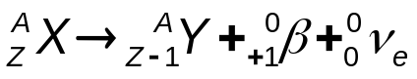

In β⁺ decay an up quark in a proton changes to a down quark.

This only happens in proton-rich nuclei.

proton (uud) → neutron (udd)

Conservation Laws

Whether reactions between particles can occur or not depends on 4 conservation laws:

- Conservation of Charge, Q
- Conservation of Baryon number, B
- Conservation of Strangeness, S
- Conservation of Lepton number, L

The 4 quantities (Q, B, S and L) have to be the same after a reaction as they were before it occurred.

Charge and Baryon Number are always conserved.

Strangeness is only conserved in the strong and electromagnetic interactions.
Electromagnetic Radiation

The Photoelectric Effect

The effect consists of the emission of electrons from a metal surface when electromagnetic waves of a high enough frequency are incident on the surface.

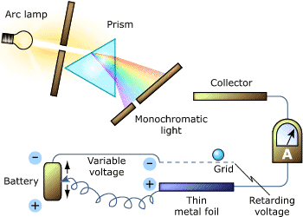

The wave nature of electromagnetic radiation cannot explain aspects of the photoelectric effect phenomenon, a particle model of radiation is necessary to explain all aspects.

Each photon has a discrete amount of energy, E, that is dependent only on the photon’s frequency.

Energy (J) = Planck’s constant (Js) × frequency (Hz)

Or E = hf

h, Planck’s constant = 6.63×10⁻³⁴Js

Difficulties of a Wave Theory

If light is considered to be only wave-like, the area of the metal that the light is shining on should receive a uniform distribution of energy.

Wave theory can’t explain why:

- The effect is only observed when the light frequency reaches a value f₀, regardless of its intensity.

- The electron emission is instantaneous even if very faint light is used, a time delay of 1000 seconds would be expected.

- The maximum speed of the emitted electrons is independent of the intensity of the incident radiation.

The Photoelectric Effect suggests the particle nature of light.
Einstein’s Photoelectric Equation

The energy needed to remove an electron from the surface of a metal is called the work function, φ.

Photoemission only occurs when: E > φ

hf > φ

Photoemission only occurs when f reaches a certain value, called the threshold frequency, f₀.
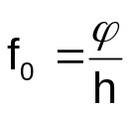

When f > f₀ the photon carries more energy than is required to liberate the photon and the photoelectron gains kinetic energy (J):

hf = φ + E_{k} (SI Units)

Energy of photon = Work function + E_{k} of e⁻

This kinetic energy is the maximum kinetic energy the electron may possess. If it is emitted from beneath the metal’s surface, the value will be less.

The Laws of Photoelectric Emission:

- When the incident light is monochromatic, the number of electrons emitted per second is proportional to the light intensity. (Emission occurs effectively instantaneously)

- The kinetic energy of the emitted electrons (photoelectrons) varies from 0 to a maximum value. This definite maximum and the electron energy distribution depend only on the frequency of the light and NOT on its intensity.

- Electrons are not emitted when the light has a frequency lower than a certain threshold value f₀. The value of f₀ varies from metal to metal.

Questions:

- EM radiation of frequency 0.88×10¹⁵Hz falls upon a surface whose work function is 2.5eV. Calculate the maximum kinetic energy of the photoelectrons released from the surface.

- Sodium has a work function of 2.3eV. Calculate;
  - Its threshold frequency.
  - The maximum speed of the photoelectrons produced when the sodium is illuminated by light of wavelength 5×10⁻⁷m.
Ionisation and Excitation

Electrons in their lowest energy levels are said to be in the ground state. Electrons that gain energy and move to higher energy levels are said to be excited. When electrons gain enough energy to leave their parent atom, the atom is said to be ionized and is described as an ion.

Electrons might move to higher energy levels or leave their parent atom because of absorption of EM radiation or by collision with a free electron.

The Fluorescent Tube

Ionisation is the removal of one or more of the electrons in an atom, leaving the atom positively charged.

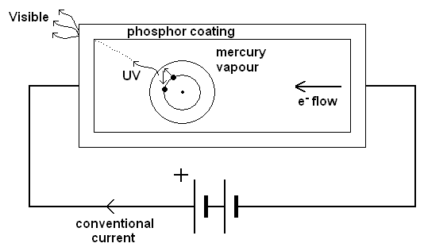

- Electrons flow through the mercury vapour.
- Electrons collide with atomic electrons and excite them.
- Atomic electron returns to ground state emitting a UV photon.
- Phosphor absorbs UV photon and emits several visible photons.

Energy Levels

All charged particles emit radiation when they are accelerated.

Electrons orbiting nuclei do not.

Bohr suggested that electrons could travel in certain orbits without losing energy, so-called energy levels.

Evidence for his theory can be observed using vapours that have electric currents passed through, using a diffraction grating.

A series of bright emission lines are observed at certain frequencies for different elements.

Spectral lines of atomic hydrogen:
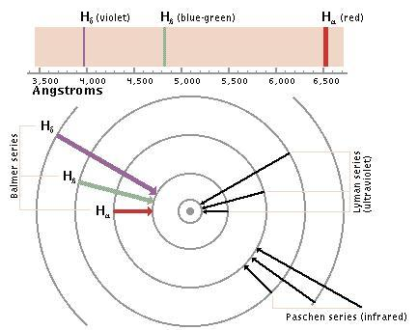
These bright emission lines are caused by electrons moving from higher energy levels to lower energy levels emitting photons of light in the process.
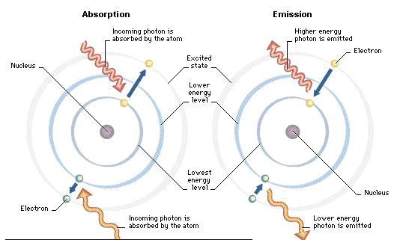

Energy levels in a hydrogen atom:

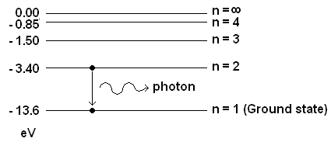

Negative energy because the electron is bound to the atom.

Energy needs to be transferred to the electron to free it from the atom.

At infinity the energy possessed by the electron is zero.

Energy of emitted photon = E₁ – E₂ = ΔE = hf or hf = E₁ – E₂

Electrons can only move between these allowed energy levels, they can only gain / lose specific amounts of energy.

Different elements have different energy levels and, therefore, have different spectral lines.

Wave Particle Duality

Wave theory successfully explains reflection, refraction and diffraction of light.

Electrons, however, supposedly particles can be diffracted by directing a beam of them at a thin slice of crystal.

Particles can’t be diffracted, so electrons must be waves!

Electron diffraction suggests the wave nature of particles.

(The photoelectric effect suggests the particle nature of light.)

But electrons can be deflected by electric and magnetic fields, just like particles.

It is necessary to use a wave model of to explain some aspects of their behaviour and a particle model to explain others.

This dual nature is referred to as wave-particle duality.

deBroglie suggested that all particles have wave properties and vice versa.

This means that all particles have an associated wavelength, called the deBroglie wavelength:

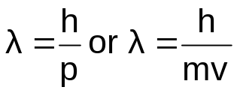
λ is the wavelength (m)
h is Planck’s constant (6.63×10⁻³⁴Js)
m is the particle’s mass (kg)
v is the particle’s velocity (ms⁻¹)

Calculate the deBroglie wavelength of an electron traveling at a velocity of 4.2×10⁷ms⁻¹.

